ULISES V5000i V2.6.X

Technical Manual

Maintenance and Logs

DT-A41-MTDT-02-26S0 

DOCUMENT REGISTRATION AND CONTROL

|  |  |  |  |
| --- | --- | --- | --- |
| **PROJECT/UNIT** | ULISES V5000i V2.6.X | ***Reference*** |  |
| **DOCUMENT** | Maintenance and Logs | ***Code*** | DT-A41-MTDT-02-26S0 |
|  |  | ***Date*** | 26/05/2020 |

|  |  |  |
| --- | --- | --- |
| **CREATED BY** | Arturo García |  |
| **DATE** | 26/05/2020 |
| **REVIEWED BY** |  |  |
| **DATE** |  |
| **VALIDATED BY** |  |  |
| **DATE** |  |

CHANGE LOG

|  |  |  |  |
| --- | --- | --- | --- |
| **R** | **Date** | **Description** | **Author** |
| 1 | 06/07/2017 | JOTRON Radio Particular Features |  |
| 2 | 23/02/2018 | Revision for version 2.5.7  Review of Radio Functionalities  Telephony Support Services  (PROXY/PRESENCE  PRESENCE AGENT)  Routing Review | Arturo García |
| 3 | 27/06/2018 | Revision for version 2.5.9 | Arturo García |
| 4 | 01/04/2019 | Revision for version 2.5.9#07 | Arturo García |
| 5 | 26/05/2020 | Revision for version 2.6.0 | Arturo García |
|  |  | #4564. Comment on the fact that NBX services can be hosted in several machines included | Arturo García |
|  |  | #4568. The definition of SPSI and SPV users corrected | Arturo García |
|  |  |  |  |
|  |  |  |  |
|  |  |  |  |
|  |  |  |  |
|  |  |  |  |
|  |  |  |  |
|  |  |  |  |
|  |  |  |  |
|  |  |  |  |
|  |  |  |  |
|  |  |  |  |
|  |  |  |  |
|  |  |  |  |
|  |  |  |  |
|  |  |  |  |
|  |  |  |  |
|  |  |  |  |
|  |  |  |  |

TABLE OF CONTENTS

1. Introduction 10

1.1. Purpose 10

1.2. Reference Documentation 10

2. Description of Hardware Architecture 11

2.1. Technical Specifications 12

3. Software Architecture 15

3.1. Client Server Structure 15

3.2. Applications 15

4. Supported Services 16

4.1. Hardware Status Supervision 16

4.2. Monitoring of Radio Operations 17

4.3. Monitoring of Presence of telephone resources 19

4.4. Log Management 20

4.4.1. Operations 20

4.4.2. Incidents recorded by the system 21

4.5. Alarm Management 24

4.6. SNMP Agent 25

4.6.1. Configuration Group. “.1.3.6.1.4.1.7916.8.1.5.1”. 25

4.6.2. General Status Group. “.1.3.6.1.4.1.7916.8.1.5.2” 25

4.6.3. Positions Group. .1.3.6.1.4.1.7916.8.1.5.3” 26

4.6.4. Gateways Group. “.1.3.6.1.4.1.7916.8.1.5.4”. 28

4.6.5. Group of Resources on External Units. “.1.3.6.1.4.1.7916.8.1.5.5” 29

4.6.6. PBX Group (PROXY). “.1.3.6.1.4.1.7916.8.1.5.6” 31

4.6.7. Radio Group. “.1.3.6.1.4.1.7916.8.1.5.7” 31

4.6.8. Group of Quality Variables of the Subsystems “.1.3.6.1.4.1.7916.8.1.5.8” 35

5. SERVER Installation 36

5.1. Install Application 36

5.1.1. Prerequisites 36

5.1.2. Process 36

5.2. Configure the Application 39

6. Usage requirements 41

6.1. Recommendations prior to use 41

7. User Guide 42

7.1. Main Page 42

7.1.1. General Structure 42

7.1.2. Alarm Management 44

7.2. Supervision Subsystem 44

7.2.1. Display of Statuses 45

7.2.2. Global Status Supervision Screen 45

7.2.2.1. General Status of Servers 1 and 2 46

7.2.2.2. General Status of the Time Subsystem (if configured on the server) 46

7.2.2.3. General Status of the Operators Subsystem 47

7.2.2.4. General Status of Centralized Operator Services 47

7.2.2.5. General Status of the Gateways Subsystem 48

7.2.2.6. General Status of the Internal PBX (if configured on the server) 48

7.2.2.7. General Status of external VOIP Resources 49

7.2.2.8. General Status of the SACTA Subsystem (if configured on the server) 49

7.2.3. CWP Supervision Screen 49

7.2.4. Gateways Supervision Screen 51

7.2.4.1. Details of Single Gateways 53

7.2.4.2. Details of Dual Gateways 55

7.2.4.3. Details of Software Version on Gateway 56

7.2.4.4. Status and Switching of CPU in Dual Gateways Method 1 57

7.2.4.5. Status and Switching of CPU in Dual Gateways Mode 2 58

7.2.5. Centralized Services Supervision Screen 58

7.2.6. PBX Subscriber Supervision Screen 59

7.2.7. Screen for Supervision of Resources on External VoIP Units 59

7.3. RADIO Operation Subsystem 62

7.3.1. Radio Sessions 62

7.3.2. M+N Manager 64

7.3.3. 1+1 Manager 66

7.3.4. Assignment Status of HF Transmitters 67

7.4. Telephone Resource Presence Subsystem 68

7.4.1. Proxy Availability 68

7.4.2. Availability of Analogue Interfaces 69

7.4.3. Subscriber Availability in Internal PBX 70

7.4.4. Availability of External ATS-SIP Subscribers 70

7.5. Log/Statistics Subsystem 71

7.5.1. Log Manager 71

7.5.2. Statistics Manager 73

7.6. Service Subsystem 75

7.6.1. General Information 76

7.6.2. Configuration of Incidents 76

7.6.3. Service Configuration 77

7.6.4. SNMP Agent 78

7.6.5. Configuration of the SACTA Interface Service 80

7.7. Identification of Application and Licence Agreements 83

8. Annex A. Centralized Services Supervision Screens. 84

8.1. General Options 85

8.1.1. Global Status 85

8.1.2. Local Pre-configuration management 87

8.2. Radio Options 88

8.2.1. Radio Sessions 88

8.2.2. M+N Manager 89

8.2.3. HF transmitters 90

8.2.4. 1+1 Manager 91

8.3. Telephony Options 91

8.3.1. Proxy Availability 91

8.3.2. Status of Analogue Interfaces 92

8.3.3. PBX Subscriber Status 93

8.3.4. Availability of External ATS-SIP Subscribers 94

8.4. Local Configuration 94

9. Annex B. Screenshots. 96

9.1. Maintenance Application. 96

9.1.1. Screenshots in English 96

9.1.2. Screenshots in French 100

9.2. Nodebox 106

9.2.1. Screenshots in English 106

9.2.2. Screenshots in French 107

10. Legal Information 108

11. GLOSSARY 110

INDEX OF FIGURES

Figure 1. Architecture of the ULISES V 5000-I Management Network 11

Figure 2. Server Installation. Presentation Screen. 36

Figure 3. Server Installation. Accept Terms of the contract. 37

Figure 4. Server Installation. IP Configuration. 37

Figure 5. Server Installation. Confirm the Installation 38

Figure 6. Server Installation. Installing the files and starting services. 38

Figure 7. Server Installation. Installation completed. 39

Figure 8. Server Installation. Maintenance Application. 39

Figure 9. Server Installation. Configure the Application. 40

Figure 10. Maintenance Application. Home Page. 42

Figure 11. Maintenance Application. General Supervision Screen. 46

Figure 12. Maintenance Application. CWP Supervision. 50

Figure 13. Maintenance Application. Gateways Supervision Screen. 51

Figure 14. Maintenance Application. Details of a Single Gateway. 53

Figure 15. Maintenance Application. Details of a Dual Gateway. 55

Figure 16. Maintenance Application. Gateway Software Version. 56

Figure 17. Maintenance Application. Supervision of Centralized Services. 58

Figure 18. Maintenance Application. PBX Subscriber Supervision. 59

Figure 19. Maintenance Application. Supervision of External Units. 60

Figure 20. Radio Operation Subsystem. 62

Figure 21. Radio Sessions. 63

Figure 22. M+N Manager 65

Figure 23. 1+1 Manager. 66

Figure 24. HF radio Transmitter Assignment Manager. 67

Figure 25. Telephone Resource Presence Subsystem. 68

Figure 26. SIP Proxy Availability. 68

Figure 27. Availability of Analogue interfaces 69

Figure 28. PBX Subscriber Availability. 70

Figure 29. Availability of External ATS-SIP Destinations. 70

Figure 30. Maintenance Application. Log screen. 71

Figure 31. Maintenance Application. Configuration of Log Filter. 72

Figure 32. Maintenance Application. Statistics Screen 74

Figure 33. Maintenance Application. Service Subsystem 75

Figure 34. Maintenance Application. General Information. 76

Figure 35. Maintenance Application. Incidents Configuration. 76

Figure 36. Maintenance Application. Server Configuration. 77

Figure 37. Maintenance Application. SNMP Options. 78

Figure 38. Maintenance Application. SNMP V3 Options. 79

Figure 39. Maintenance Application. SNMP V3 User. 79

Figure 40. Maintenance Application. Configuration of the SACTA Interface Service. 80

Figure 41. About 83

Figure 42. Centralized Services. General Format of the Screen. 84

Figure 43. Centralized Services. General Options. Global Status. 85

Figure 44. Centralized Services. General Options. Pre-configurations 87

Figure 45. Radio Options. Active Sessions. 89

Figure 46. Radio Options. M+N Manager (VHF) 89

Figure 47. Management of HF radio Transmitter Assignment. 90

Figure 48. 1+1 Manager. 91

Figure 49. Telephony Options. SIP Proxy Availability. 91

Figure 50. Telephony Options. Status of Analogue Interfaces. 92

Figure 51. Telephony Options. Registered Subscriber Status. 93

Figure 52. Telephony Options. Availability of External ATS-SIP Destinations. 94

Figure 53. Local Configuration. 95

INDEX OF TABLES

Table 1. Functions associated with each Element of the Management Network. 12

Table 2. Server Specifications 13

Table 3. Console specifications. 14

Table 4. Maintenance Applications 15

Table 5. List of events controlled by the system 24

Table 6. Status Indicators 45

Table 7. Floating information for CWP. 50

Table 8. Gateway control menu. 51

Table 9. Gateway Graphics according to type 52

Table 10. Floating information for gateways. 52

Table 11. Glossary of Abbreviations 111

# Introduction

## Purpose

This document describes the operating modes established in the different applications and tools that make up the Maintenance subsystem for the ULISES V 5000-I systems, version 2.5.X, which covers the control of Installations with Single and Dual gateways. This document covers the following concepts:

* General Description of Hardware and Software Architecture.
* Installation of Applications.
* User Manual for Maintenance Applications.

## Reference Documentation

|  |  |  |  |
| --- | --- | --- | --- |
| **Id** | **Code** | **Description** | **Version** |
| **[1]** | SGYER1661.100 | VOICE COMMUNICATIONS SYSTEM FOR AIR TRAFFIC CONTROL.- TECHNICAL SPECIFICATION. |  |
| **[2]** | CNSA-09-SPE-006-1.0 | OPERATIONAL REQUIREMENTS FOR CONTROL TOWER VOICE COMMUNICATIONS |  |
| **[3]** |  |  |  |
|  |  |  |  |

# Description of Hardware Architecture

From the point of view of the Maintenance and Supervision network, the ULISES V 5000-I system has the following architecture:

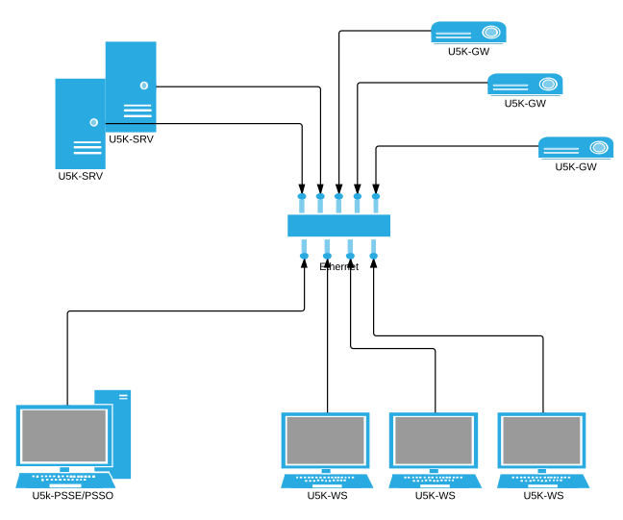

Figure 1. Architecture of the ULISES V 5000-I Management Network

The elements that make up this NETWORK and their associated functions are the following:

|  |  |
| --- | --- |
| **Element** | **Functions** |
| U5K-SRV. May be single or Dual | Database for configuration and logs. |
|  | Supervision of Positions and Gateways hardware |
|  | Time Synchronisation |
|  | Access to External Units (such as SACTA) |
|  |  |
| U5K-ERSS/ORSS | ULISES V 5000-I Configuration Client. Accessed via browser. |
|  | ULISES V 5000-I Maintenance Client. Accessed via browser. |
|  |  |
| U5K-WS | Control Working Positions |
|  |  |
| U5K-GW | Gateways |
|  |  |

Table 1. Functions associated with each Element of the Management Network.

All of these elements are connected in a Local Network. The TCP/IP connectivity configuration will form a local subnetwork.

The previous diagram represents configuration of a system with all possible elements. Some installations may not contain some of these elements, and others may take on multiple functions. For example, in a simple configuration, the server and console may reside on the same machine.

## Technical Specifications

The technical specifications of each element are as follows:

**Server**

May be equipped with dual or single servers. The recommended technical specifications for each one are the following:

| **Group** | **Element** | **Specification** |
| --- | --- | --- |
| **Processor** |  |  |
|  | ***Chipset*** | Chipset Intel® C206 |
|  | ***Processor*** | Processor Intel® Xeon® series E3 |
|  | ***Memory*** | 8 GB DDR3 |
|  | ***Expansion Slots*** | NO |
|  |  |  |
| **Storage** |  |  |
|  | ***Hard Disk*** | SATA, 3.5”, 7200 rpm: 250 GB |
|  | ***Optical Drive*** | DVD R/W |
|  |  |  |
| **Communications** |  |  |
|  | ***Network Controllers*** | Ethernet 100MB/1GB |
|  | ***USB*** | USB 2.0 |
|  | ***Serial Ports*** | RS-232 |
|  | ***Parallel Ports*** | NO |
|  | ***Other*** | NO |
|  |  |  |
| **Graphics / Audio** |  |  |
|  | ***Graphic Controller*** | Intel® 2000 high-definition graphics |
|  | ***Monitor*** | 21" 16x9 |
|  | ***Audio Card*** | Realtek ALC262 integrated high-definition audio |
|  | ***Speakers*** | Integrated |
|  |  |  |
| **Software** |  |  |
|  | ***OS*** | Windows 10 Professional 64 BITS |
|  | ***Drivers*** | NO |
|  | ***SGBD*** | NO |
|  |  |  |
| **Other** |  |  |
|  | ***Format*** | Rackable 19"-3U |
|  | ***Power Supply*** | 600 w |
|  |  |  |

Table 2. Server Specifications

**ERSS/ORSS**

| **Group** | **Element** | **Specification** |
| --- | --- | --- |
| **Processing** |  |  |
|  | ***Chipset*** | Chipset Intel® C206 |
|  | ***Processor*** | Processors Intel® Core™ i5 or i7 second generation |
|  | ***Memory*** | 8 GB DDR3 |
|  | ***Expansion Slots*** | NO |
|  |  |  |
| **Storage** |  |  |
|  | ***Hard Disk*** | SATA, 3.5”, 7200 rpm: 250 GB |
|  | ***Optical Drive*** | NO |
|  |  |  |
| **Communications** |  |  |
|  | ***Network Controllers*** | Ethernet 100MB/1GB |
|  | ***USB*** | USB 2.0 |
|  | ***Serial Ports*** | NO |
|  | ***Parallel Ports*** | NO |
|  | ***Other*** | NO |
|  |  |  |
| **Graphics / Audio** |  |  |
|  | ***Graphic Controller*** | Intel® 2000 high-definition graphics |
|  | ***Monitor*** | 21" 16x9 |
|  | ***Audio Card*** | Realtek ALC262 integrated high-definition audio |
|  | ***Speakers*** | Integrated |
|  |  |  |
| **Software** |  |  |
|  | ***OS*** | Windows 10 pro 64 BITS |
|  | ***Drivers*** | NO |
|  | ***SGBD*** | NO |
|  |  |  |
| **Other** |  |  |
|  | ***Format*** | Mini-tower |
|  | ***Power Supply*** | 400 w |
|  |  |  |

Table 3. Console specifications.

In the cases in which the server and console are located in the same machine, the specifications defined for the server will take precedence.

# Software Architecture

## Client Server Structure

From the point of view of software, the applications are organized into a Local Network infrastructure, in which two types of elements coexist.

Servers. These implement the supports for consolidated databases (configuration and logs) and they provide support for network-distributed functions and automatic or “BACKGROUND” processes that must be implemented in the different functional modules that make up the system.

Operating Programs or Consoles. These offer access to the user interface (HMI) for the system operators. Due to the nature of the system, the user interfaces offered are web interfaces.

The following services have been developed on this model:

* Hardware Status Supervision Service.
* Radio and Telephony Operation Monitoring Service.
* Log Management Service.
* Alarm Management Service.

## Applications

The service architecture described above is structured into a series of applications, each of which may contain one or more components, as described in the table below:

|  |  |  |
| --- | --- | --- |
| **Application** | **Location** | **Associated Services** |
| U5kManServer | Server | Time synchronisation |
|  |  | Hardware Status Supervision |
|  |  | Monitoring of Radio and Telephony Operations |
|  |  | Alarm Management |
|  |  | Log Management |
|  |  | Web server |
|  |  | SNMP Agent |

Table 4. Maintenance Applications

In terms of the application model, the server is structured on a Windows ‘service’ and the Console application is structured as a web application located on the U5K-SRV server.

# Supported Services

## Hardware Status Supervision

All the elements that make up the maintenance network (including the active elements of the VCS) are monitored so that they report their operational status and the status of their associated elements to each other.

This information is collected and maintained online in the server program, and may be queried from the client programs (consoles). The supervised installation elements are the following:

Services Status. The ULISES V 5000-I management network maintains a status frame in its local network communications, indicating the presence or absence (with associated diagnostic codes) of each one of the possible services. This information is presented on clients making it possible to obtain the following information:

* Status of Servers.
* Overall Gateway Status (U5K-GW).
* Overall Status of Control Working Positions (U5K-WS).
* Overall Status of Resources on VoIP Units.
* Location of the Internal PBX Service[1] and access to management pages of the service.
* Location of Centralised services and access to their Supervision pages.
* Location of the Synchronisation Pattern.
* Location and status of Higher Management Networks (in our case, only SACTA).

Control Working Positions. For each one of the physical positions configured, the maintenance and supervision subsystem shows the operating status of:

* Presence of the Unit on the management network.
* Presence of the application (panel) and its status (operational or STANDBY).
* Operational status of LAN interfaces.
* Presence of Associated Radio Speakers or Speaker.
* Presence of Associated Telephony (Hotline) Speaker.
* Presence of Headphones inserted into Executive JACK.
* Presence of Headphones inserted into Assistant JACK.
* Presence of the positions’s analogue recording cable.

Gateways. For each one of the physical gateways configured, the maintenance and supervision subsystem shows the operating status of:

* Presence of the Unit on the Management Network. In the case of DUAL gateways, the status of both physical gateways and identification of the main and standby will be displayed.
* Operational status of LAN interfaces.
* Insertion status of slave cards or interface cards.
* Interfaces. The system maintains a status table that corresponds to each one of the channel interfaces in the system. Each one of these interfaces is associated with a gateway. The following information is maintained for each unit:
  + Associated interface card (in each gateway).
  + Position in the interface.
  + Name of the associated communications resource.
  + Type of physical interface and signalling protocol (Radio, Telephony SB/LB/CB, R2/N5 Telephony, NEHL, etc.).
  + Status of the Interface to the resource. Indicating which are functioning correctly and which are in a fault status.

PBX Subscribers[2]. For each one of the internal Subscribers of the PBX, the maintenance and supervision subsystem shows:

* The associated Resource identifier.
* The Registration status of the resource in the internal PBX.

Resources on VoIP Units. For each one of the Resources on VoIP units (Radios, IP Telephones and IP Recorders) configured in the system, the following is displayed:

* The associated Resource identifier.
* Unit type (Radio or Telephony).
* The associated IP address.
* The IP connectivity of the Unit.
* The SIP connectivity of the Unit.

## Monitoring of Radio Operations

The status of radio operation is communicated online to the maintenance service, which provides the necessary tools to communicate the information on the status to the operators. The following information on radio operations is supplied by the system:

Status of Radio sessions. For each frequency configured in the system and assigned to a sector, the following information is displayed:

* Frequency ID. Additionally:
  + Type of Frequency (single or multiple)
  + Session priority (Normal, Emergency)
  + Presence of 1+1 elements
  + TX mode (CLIMAX or BTS, only in multiple frequencies)
  + CLIMAX mode (Absolute or Relative, only in frequencies in the TX CLIMAX mode)
  + BSS method selected (RSSI, NUCLEO-RSSI, only in the case of multiple frequencies or in single frequencies with the presence of 1+1 elements)
  + BSS Window (expressed in milliseconds, only in the case of multiple frequencies or in single frequencies with the presence of 1+1 elements)
* Operating Status
  + Out-of-service frequency
  + Operating frequency
  + Operating frequency in the Degraded mode (in frequencies with multiple sites)
* Reception element selected. Only in the presence of SQH, it shows the Site, Resource ID and the qualification note of the element selected for reception.
* Transmission mode or Transmission site selected.
* List of SIP sessions associated with the frequency, and for each session:
  + Resource site.
  + Session Type.
  + Associated URI.
  + Operating Status.
  + Session parameters, including:
    - RTP ports.
    - Transmission and Reception synchronisation parameters.

1+1 Subsystem status. Shows the following data for each frequency with 1+1 elements in its composition:

* Elements making up the frequency in each site.
* Operating status of the transmission and reception resources.
* Transmission unit selected as active in each site.
* Manual selection control of the selected transmitter.
* Receiver enabling control in each site.

Status of Assignment of Radio Units to Frequencies (M+N Manager). Shows a map of the assignment status of VOIP units to operating frequencies. By groupings by Sites and frequency band, the following information is displayed for each VOIP unit:

* Unit Identifier.
* IP Address of the Unit.
* Unit Type (Main (M) or Standby (S)).
* Relative Priority of the Frequency associated with a Main Unit (M).
* Operating Status.
* Assigned Frequency.
* SIP connectivity status.

Assignment Status of HF Radio Transmitters to Operators. Shows a map of the assignment status of HF radio transmitters to operators. The following information is displayed for each configured HF Transmitter:

* Unit Identifier.
* IP Address of the unit’s remote-control manager.
* OID (address for SNMP) of the unit in the remote-control manager.
* Status of the unit for Remote control.
* User (Operator) to which the unit is (or is not) assigned.
* Frequency to which the unit is tuned (for assigned units).
* URI associated with the transmitter’s radio resource.

## Monitoring of Presence of telephone resources

The presence of internal or external telephone resources is communicated online[3] to the maintenance service, which provides the necessary tools to communicate the information on the status to the operators. The system provides the following information:

Presence of PROXIES configured in the system. Shows a list of the ENDPOINTS that have been configured as PROXY, either internal or for an external dependence. The following information is displayed for each one of these elements:

* Identifier of the Dependence to which the PROXY belongs.
* Type of Proxy (internal, external, main, alternative).
* IP / Port that is being polled to detect its activity.
* Status (Available or not Available).

Presence of Analogue Telephony Interfaces on Gateway. For each gateway that reports its activity, displays a list of resources / **operational** interfaces on the gateway. The following information is shown for each resource:

* Resource Type. May be normal telephony (1) or NEHL (2).
* Resource identifier.

Availability of PBX Subscribers (except for the operator positions themselves). Shows the subscribers (telephones) registered on the PBX, which have also been configured as Telephony resources in the VCS. The following information is displayed for each subscriber:

* Identifier.
* Associated URI.

Availability of External ATS/SIP Subscribers (Users/Sectors from other VCSs). Shows a list of the external ATS/SIP Destinations that have been configured as such in the system. The following information is shown for each destination:

* Dependence to which they correspond.
* URI associated with the subscriber (presence URI).
* Status, available or not available.

## Log Management

The log management service is the only element in the system that has direct access to the incident table. When the clients need to ‘archive’ an event, they do this by exchanging frames in this service.

The file is supported on the system’s Overall Database, which in addition to maintaining the incident LOG, gives it literal (ID) management support, which optimizes the size of the files.

Each incident record contains information regarding:

* Date and time when the incident occurred.
* Incident Code. Digit that identifies the type of incident.
* Incident Group (General, operators, gateways, etc.).
* Hardware element (Subsystem, Gateway or Operator) involved in the incident.
* Information associated with the gateway in STRING format.
* Date and time of acknowledgement, if an alarm was generated.
* User who acknowledged, if the incident generated an alarm.

### Operations

In regard to the General Log Archive, this service offers the following functions and operations:

Log Table Supervision. The SERVER process is programmed to maintain a certain quantity (days) of incidents in the Log, preventing the table from collapsing due to an excessive number of records.

Use of the information contained in the tables. The HMI elements incorporate the options that are needed to use the information contained in these tables. These functions are:

* Display on Screen the records contained in the selected file.
* Apply filters to the selected file. These filters include:
  + Start and/or End Date and Time.
  + Incident Group.
  + Hardware Element.
  + Incident Code.
  + Generic Text.
* Generate Reports in PDF of the displayed records.

### Incidents recorded by the system

The following incidents are recorded by the system:

| ID | Group | Incident | Comment |
| --- | --- | --- | --- |
| 1 | HF | HF Unit connected. |  |
| 2 | HF | Error in HF unit. |  |
| 3 | HF | HF Unit disconnected. |  |
| 4 | HF | HF Unit assigned. |  |
| 5 | HF | HF Unit released. |  |
| 6 | HF | General HF Error. |  |
| 7 | HF | HF assignment error. |  |
| 8 | HF | HF unassignment error. |  |
| 9 | HF | Multiple HF assignment error. |  |
| 10 | HF | SELCAL HF preparation error. |  |
| 50 | GENERAL | Service INFO. |  |
| 51 | GENERAL | Service ERROR. |  |
| 96 | GENERAL | Day change. |  |
| 101 | GENERAL | VCS selection. |  |
| 105 | GENERAL | Loading of sectorization. |  |
| 106 | GENERAL | Loading sectorization error. |  |
| 108 | GENERAL | Sectorization rejected. All of the real sectors are not present. |  |
| 109 | GENERAL | Automatic sectorization implemented. |  |
| 110 | GENERAL | Automatic sectorization rejected. |  |
| 111 | GENERAL | Sector assigned to position. |  |
| 112 | GENERAL | Sector unassigned from the position. |  |
| 113 | GENERAL | Sectorization rejected. 1 + 1 not active. |  |
| 201 | GENERAL | Server 1 active. |  |
| 202 | GENERAL | Server 1 down. |  |
| 203 | GENERAL | Server 2 active. |  |
| 204 | GENERAL | Server 2 down. |  |
| 300 | GENERAL | NBX management. |  |
| 301 | GENERAL | NBX alarm. |  |
| 1001 | POSITION | OP input. |  |
| 1002 | POSITION | OP down. |  |
| 1003 | POSITION | Connection of executive JACKS. |  |
| 1004 | POSITION | Disconnection of executive JACKS. |  |
| 1005 | POSITION | Connection of assistant JACKS. |  |
| 1006 | POSITION | Disconnection of assistant JACKS. |  |
| 1007 | POSITION | Speaker connected. |  |
| 1008 | POSITION | Speaker disconnected. |  |
| 1009 | POSITION | Panel goes into operation. |  |
| 1010 | POSITION | Panel switches to STANDBY. |  |
| 1011 | POSITION | Page of frequencies selected. |  |
| 1014 | POSITION | PTT status. |  |
| 1015 | POSITION | Facility selected. |  |
| 1016 | POSITION | Incoming call in Position. |  |
| 1017 | POSITION | Outgoing call in Position. |  |
| 1019 | POSITION | End of call in Position. |  |
| 1020 | POSITION | Telephone call established. |  |
| 1021 | POSITION | BRIEFING function. |  |
| 1022 | POSITION | GLP replay. |  |
| 1023 | POSITION | Recording cable connected. |  |
| 1024 | POSITION | Recording cable disconnected. |  |
| 1025 | POSITION | LAN event. |  |
| 2001 | GW | GW in. |  |
| 2002 | GW | GW down. |  |
| 2003 | GW | Connection of Radio Resource. |  |
| 2004 | GW | Disconnection of Radio Resource. |  |
| 2005 | GW | Connection of Telephony Resource. |  |
| 2006 | GW | Disconnection of Telephony Resource. |  |
| 2007 | GW | Connection of interface card. |  |
| 2008 | GW | Disconnection of interface card. |  |
| 2009 | GW | Connection of R2 Resource. |  |
| 2010 | GW | Disconnection of R2 Resource. |  |
| 2012 | GW | LCN protocol error. |  |
| 2013 | GW | Connection of LCN Resource. |  |
| 2014 | GW | Disconnection of LCN Resource. |  |
| 2015 | GW | Connection of N5 Resource. |  |
| 2016 | GW | Disconnection of N5 Resource. |  |
| 2017 | GW | Connection of QSIG Resource. |  |
| 2018 | GW | Disconnection of QSIG Resource. |  |
| 2020 | GW | R2 incoming call. |  |
| 2021 | GW | End of R2 incoming call. |  |
| 2022 | GW | R2 outgoing call. |  |
| 2023 | GW | End of R2 outgoing call. |  |
| 2024 | GW | R2 test call. |  |
| 2025 | GW | R2 protocol error. |  |
| 2030 | GW | LCN incoming call. |  |
| 2031 | GW | End of LCN incoming call. |  |
| 2032 | GW | LCN outgoing call. |  |
| 2033 | GW | End of LCN outgoing call. |  |
| 2040 | GW | Incoming telephone call. |  |
| 2041 | GW | End of incoming telephone call. |  |
| 2042 | GW | Outgoing telephone call. |  |
| 2043 | GW | End of outgoing telephone call. |  |
| 2050 | GW | PTT ON. |  |
| 2051 | GW | PTT Off. |  |
| 2052 | GW | SQ ON. |  |
| 2053 | GW | SQ Off. |  |
| 2100 | GW | Selection Main/Standby. |  |
| 2200 | GW | Gateway Event. |  |
| 2300 | GW | Local Operation on Gateway. |  |
| 3001 | EXT | External Unit In. |  |
| 3002 | EXT | External Unit Down. |  |
| 3003 | EXT | Internal PBX Subscriber In. |  |
| 3004 | EXT | Internal PBX Subscriber down. |  |
| 3050 | M+N | MN. Unit Available. |  |
| 3051 | M+N | MN. Malfunctioning Equipment. |  |
| 3052 | M+N | MN. Error in Communication with Unit. |  |
| 3060 | M+N | MN. Frequency TX in MAIN Unit. |  |
| 3061 | M+N | MN. Frequency TX in STANDBY Unit. |  |
| 3062 | M+N | MN. Frequency TX not available. |  |
| 3063 | M+N | MN. Frequency TX not available. Low Priority. |  |
| 3064 | M+N | MN. Frequency Rx in MAIN Unit. |  |
| 3065 | M+N | MN. Frequency Rx in STANDBY Unit. |  |
| 3066 | M+N | MN. Frequency Rx not available. |  |
| 3067 | M+N | MN. Frequency Rx not available. Low Priority. |  |
| 3070 | M+N | MN. Manual Operation. |  |
| 3071 | M+N | MN. Error in Manual Operation. |  |
| 3080 | M+N | MN. Information. |  |
| 3081 | M+N | MN. Generic Error. |  |
| 3082 | M+N | MN. Configuration Error. |  |
| 5000 | STATISTICS | Operating time counter. |  |
| 5001 | STATISTICS | Element goes into operational status. |  |
| 5002 | STATISTICS | Element leaves operational status. |  |
| 5003 | STATISTICS | Operating time counter. |  |
| 5004 | STATISTICS | Element goes into malfunctioning status. |  |
| 5005 | STATISTICS | Element leaves malfunctioning status. |  |

Table 5. List of events controlled by the system

## Alarm Management

A set of the incidents stored by the log service can be configured to be considered as important events that deserve the attention of the system operator. These incidents will be called “*alarms*” and they require special handling by the program.

The server notifies the different consoles that are connected of the incidents that are considered to be alarms that are being recorded. This allows an incident summary to be displayed on the clients, with online refresh, as well as the possibility of acknowledging the alarms.

The number of unacknowledged alarms that the system can maintain is limited and can be configured by means of the server parameters (See 5.2).

## SNMP Agent

The system may be supervised by elements that are higher in the hierarchy. To do this, an SNMP agent has been implemented, along with a public MIB that can be queried, for the purposes of supervision, by those higher-level hierarchical elements.

This agent implements the SNMPV1/V2/V3 protocol and offers the public MIBs defined in ED137B, for the case of supervision. The public MIBs implemented are:

* SNMPv2-MIB. It includes the following subsets:
  + iso.org.dod.internet.mgnt.mibs-2.system
  + iso.org.dod.internet.mgnt.mibs-2.interfaces.
  + iso.org.dod.internet.mgnt.mibs-2.ip
  + iso.org.dod.internet.mgnt.mibs-2.tcp
  + iso.org.dod.internet.mgnt.mibs-2.udp
  + iso.org.dod.internet.mgnt.mibs-2.snmp
  + iso.org.dod.internet.mgnt.mibs-2.rmon.alarm
  + iso.org.dod.internet.mgnt.mibs-2..rmon.event

A private MIB with specific information on the system status has also been implemented. The private MIB is connected on the OID “.1.3.6.1.4.1.7916.8.1.5” which will be accessible by third-party managers (ORION) through SNMPv2 with the following information:

### Configuration Group. “.1.3.6.1.4.1.7916.8.1.5.1”.

Made up of the following fields.

|  |  |
| --- | --- |
| Field | Description (MIB) |
| cfgServDual | OBJECT-TYPE SYNTAX INTEGER {nodual(0),dual(1)} STATUS current  DESCRIPTION "Dual Server"  ::= { config 1 } |
| cfgPbx | OBJECT-TYPE SYNTAX INTEGER {no(0),si(1)} STATUS current  DESCRIPTION “PBX Supervision"  ::= { config 2 } |
| cfgSacta | OBJECT-TYPE SYNTAX INTEGER {no(0),si(1)} STATUS current  DESCRIPTION “SACTA Supervision"  ::= { config 3 } |
| cfgNtpServer | OBJECT-TYPE SYNTAX INTEGER {no(0),si(1)} STATUS current  DESCRIPTION "Time Reference Supervision"  ::= { config 4 } |

### General Status Group. “.1.3.6.1.4.1.7916.8.1.5.2”

Made up of the following fields:

|  |  |  |
| --- | --- | --- |
| Field | Description (MIB) | |
| stdVersion | OBJECT-TYPE SYNTAX DisplayString MAX-ACCESS read-only STATUS current  DESCRIPTION "Maintenance Service Version"  ::= { stdgral 1 } | |
| stdCfgact | OBJECT-TYPE SYNTAX DisplayString MAX-ACCESS read-only STATUS current  DESCRIPTION "Active VCS configuration version"  ::= { stdgral 2 } | |
| stdgTable | **General Element Status Table** | |
|  | stdDisp | OBJECT-TYPE SYNTAX DisplayString MAX-ACCESS read-only STATUS current  DESCRIPTION "Description of the element"  ::= { stdg-item 2 } |
|  | stdgIp | OBJECT-TYPE SYNTAX DisplayString MAX-ACCESS read-only STATUS current  DESCRIPTION "IP address of the element”  ::= { stdg-item 3 } |
|  | stdgStd | OBJECT-TYPE SYNTAX INTEGER {noinfo(0), ok(1), aviso-rec(2), alarma-rec(3), aviso(4), alarma(5), error(6), ppal(7), rsva(8) } STATUS current  DESCRIPTION "Operating status of the element”  ::= { stdg-item 4 } |
|  | stdgLans[4] | OBJECT-TYPE SYNTAX OCTET STRING (SIZE(8)) STATUS current  DESCRIPTION "LANs status. LAN1..LAN8"  ::= { stdg-item 5 } |
|  | stdgSync[5] | OBJECT-TYPE SYNTAX DisplayString MAX-ACCESS read-only STATUS current  DESCRIPTION "NTP client status"  ::= { stdg-item 6 } |

### Positions Group. .1.3.6.1.4.1.7916.8.1.5.3”

Made up of the following fields.

|  |  |  |
| --- | --- | --- |
| Field | Description (MIB) | |
| puestosStdg | OBJECT-TYPE SYNTAX INTEGER {noinfo(0), ok(1), aviso-rec(2), alarma-rec(3), aviso(4), alarma(5), error(6) } STATUS current  DESCRIPTION "General Status of the Operator Position subsystem"  ::= { puestos 1 } | |
| puestos-table | **Position Status Table. 1 Row for each configured position** | |
|  | puestosDisp | OBJECT-TYPE SYNTAX DisplayString MAX-ACCESS read-only STATUS current  DESCRIPTION "Position ID"  ::= { puestos-item 2 } |
|  | puestosIp | OBJECT-TYPE SYNTAX DisplayString MAX-ACCESS read-only STATUS current  DESCRIPTION "IP address of the Position”  ::= { puestos-item 3 } |
|  | puestosStd | OBJECT-TYPE SYNTAX INTEGER {noinfo(0), ok(1), aviso-rec(2), alarma-rec(3), aviso(4), alarma(5), error(6) } STATUS current  DESCRIPTION "Operating status of the Position”  ::= { puestos-item 4 } |
|  | puestosLans[6] | OBJECT-TYPE SYNTAX OCTET STRING (SIZE(8)) STATUS current  DESCRIPTION "LANs status. LAN1..LAN8"  ::= { puestos-item 5 } |
|  | puestosSync[7] | OBJECT-TYPE SYNTAX DisplayString MAX-ACCESS read-only STATUS current  DESCRIPTION "NTP client status"  ::= { puestos-item 6 } |
|  | puestosUris[8] | OBJECT-TYPE SYNTAX DisplayString MAX-ACCESS read-only STATUS current  DESCRIPTION "URIS assigned to the position"  ::= { puestos-item 7 } |

### Gateways Group. “.1.3.6.1.4.1.7916.8.1.5.4”.

Made up of:

|  |  |  |
| --- | --- | --- |
| Field | Description (MIB) | |
| pasarelasStdg | OBJECT-TYPE SYNTAX INTEGER {noinfo(0), ok(1), aviso-rec(2), alarma-rec(3), aviso(4), alarma(5), error(6) } STATUS current  DESCRIPTION "General status of the Gateway subsystem"  ::= { pasarelas 1 } | |
| pasarelasTable | **Gateways Table. One row for each Gateway configured in the system.** | |
|  | pasarelasDisp | OBJECT-TYPE SYNTAX DisplayString MAX-ACCESS read-only STATUS current  DESCRIPTION "Gateway ID"  ::= { pasarelas-item 2 } |
|  | pasarelasIp | OBJECT-TYPE SYNTAX DisplayString MAX-ACCESS read-only STATUS current  DESCRIPTION "IP address of the Gateway"  ::= { pasarelas-item 3 } |
|  | pasarelasStd | OBJECT-TYPE SYNTAX INTEGER {noinfo(0), ok(1), aviso-rec(2), alarma-rec(3), aviso(4), alarma(5), error(6) } STATUS current  DESCRIPTION "General status of the gateway"  ::= { pasarelas-item 4 } |
|  | pasarelasLans[9] | OBJECT-TYPE SYNTAX OCTET STRING (SIZE(8)) STATUS current  DESCRIPTION "LANs status. LAN1..LAN8"  ::= { pasarelas-item 5 } |
|  | pasarelasSync[10] | OBJECT-TYPE SYNTAX DisplayString MAX-ACCESS read-only STATUS current  DESCRIPTION "NTP client status"  ::= { pasarelas-item 6 } |
|  | pasarelasHw[11] | OBJECT-TYPE SYNTAX OCTET STRING (SIZE(6)) STATUS current  DESCRIPTION "CGW1-IA41-IA42-IA43-IA44-CGW2 card status"  ::= { pasarelas-item 7 } |
| radioTable | **LEGACY (Radio) Interfaces Table. One row for each LEGACY Radio Interface configured in the system.** | |
|  | radioDisp | OBJECT-TYPE SYNTAX DisplayString MAX-ACCESS read-only STATUS current  DESCRIPTION "Radio interface ID”  ::= { radio-item 2 } |
|  | radioStd | OBJECT-TYPE SYNTAX INTEGER {noinfo(0), ok(1), aviso-rec(2), alarma-rec(3), aviso(4), alarma(5), error(6) } STATUS current  DESCRIPTION "Operating status of the radio interface"  ::= { radio-item 3 } |
|  | radioUri | OBJECT-TYPE SYNTAX DisplayString MAX-ACCESS read-only STATUS current  DESCRIPTION "URI associated with the radio interface"  ::= { radio-item 4 } |
| telefTable | **LEGACY (Telephony) Interfaces Table. One Row for each LEGACY Telephony Interface configured in the system.** | |
|  | telefDisp | OBJECT-TYPE SYNTAX DisplayString MAX-ACCESS read-only STATUS current  DESCRIPTION "Telephony interface ID"  ::= { telef-item 2 } |
|  | telefTipo | OBJECT-TYPE SYNTAX INTEGER {lce(1), bc(2), bl(3), ab(4), r2(5), n5(6), em1(50), em2(51)} STATUS current  DESCRIPTION "Interface Type"  ::= { telef-item 3 } |
|  | telefStd | OBJECT-TYPE SYNTAX INTEGER {noinfo(0), ok(1), aviso-rec(2), alarma-rec(3), aviso(4), alarma(5), error(6) } STATUS current  DESCRIPTION "Operating status of the telephony interface”  ::= { telef-item 4 } |
|  | telefUri | OBJECT-TYPE SYNTAX DisplayString MAX-ACCESS read-only STATUS current  DESCRIPTION "URI associated with the telephony interface"  ::= { telef-item 5 } |

### Group of Resources on External Units. “.1.3.6.1.4.1.7916.8.1.5.5”

Made up of:

|  |  |  |
| --- | --- | --- |
| Field | Description (MIB) | |
| radioExtTable | **Table of Resources on External Radio Units. One row for each external radio unit configured in the system.** | |
|  | radioExtDisp | OBJECT-TYPE SYNTAX DisplayString MAX-ACCESS read-only STATUS current  DESCRIPTION "External radio unit ID"  ::= { radio-ext-item 2 } |
|  | radioExtIp | OBJECT-TYPE SYNTAX DisplayString MAX-ACCESS read-only STATUS current  DESCRIPTION "Address associated with the external unit"  ::= { radio-ext-item 3 } |
|  | radioExtStd | OBJECT-TYPE SYNTAX INTEGER {noinfo(0), ok(1), aviso-rec(2), alarma-rec(3), aviso(4), alarma(5), error(6) } STATUS current  DESCRIPTION "Operating status associated with the external unit"  ::= { radio-ext-item 4 } |
|  | radioExtUri | OBJECT-TYPE SYNTAX DisplayString MAX-ACCESS read-only STATUS current  DESCRIPTION "URI associated with the external unit"  ::= { radio-ext-item 5 } |
| telefExtTable | **Table of Resources on External Telephony Units. One row for each external telephony unit configured in the system.** | |
|  | telefExtDisp | OBJECT-TYPE SYNTAX DisplayString MAX-ACCESS read-only STATUS current  DESCRIPTION "External unit ID"  ::= { telef-ext-item 2 } |
|  | telefExtIp | OBJECT-TYPE SYNTAX DisplayString MAX-ACCESS read-only STATUS current  DESCRIPTION "IP Address associated with the external unit"  ::= { telef-ext-item 3 } |
|  | telefExtStd | OBJECT-TYPE SYNTAX INTEGER {noinfo(0), ok(1), aviso-rec(2), alarma-rec(3), aviso(4), alarma(5), error(6) } STATUS current  DESCRIPTION "Operating status associated with the external unit"  ::= { telef-ext-item 4 } |
|  | telefExtUri | OBJECT-TYPE SYNTAX DisplayString MAX-ACCESS read-only STATUS current  DESCRIPTION "URI associated with the external unit"  ::= { telef-ext-item 5 } |
| recsExtTable | **Table of IP Recorders. One row for each IP Recorder configured in the system.** | |
|  | recsExtDisp | OBJECT-TYPE SYNTAX DisplayString MAX-ACCESS read-only STATUS current  DESCRIPTION "ID associated with the recording unit."  ::= { recs-ext-item 2 } |
|  | recsExtIp | OBJECT-TYPE SYNTAX DisplayString MAX-ACCESS read-only STATUS current  DESCRIPTION "IP Address associated with the recording unit"  ::= { recs-ext-item 3 } |
|  | recsExtstd | OBJECT-TYPE SYNTAX INTEGER {noinfo(0), ok(1), aviso-rec(2), alarma-rec(3), aviso(4), alarma(5), error(6) } STATUS current  DESCRIPTION "Operating status associated with the recording unit"  ::= { recs-ext-item 4 } |

### PBX Group (PROXY). “.1.3.6.1.4.1.7916.8.1.5.6”

Made up of:

|  |  |  |
| --- | --- | --- |
| Field | Description (MIB) | |
| pbxStdg | OBJECT-TYPE SYNTAX INTEGER {noinfo(0), ok(1), aviso-rec(2), alarma-rec(3), aviso(4), alarma(5), error(6) } STATUS current  DESCRIPTION "Operating status of the internal system PROXY service”  ::= { pbx 1 } | |
| abonsTable | **Subscriber Table. One row for each subscriber configured in the system.** | |
|  | abonsDisp | OBJECT-TYPE SYNTAX DisplayString MAX-ACCESS read-only STATUS current  DESCRIPTION "ID associated with the subscriber."  ::= { abons-item 2 } |
|  | abonsIp | OBJECT-TYPE SYNTAX DisplayString MAX-ACCESS read-only STATUS current  DESCRIPTION "IP address of the subscriber”  ::= { abons-item 3 } |
|  | abonsStd | OBJECT-TYPE SYNTAX INTEGER {noinfo(0), ok(1), aviso-rec(2), alarma-rec(3), aviso(4), alarma(5), error(6) } STATUS current  DESCRIPTION "Operating status of the subscriber”  ::= { abons-item 4 } |

### Radio Group. “.1.3.6.1.4.1.7916.8.1.5.7”

Made up of:

|  |  |  |
| --- | --- | --- |
| Field | Description (MIB) | |
| rdsesNum | Number of radio sessions. | |
| rdsesTable | **Table of Radio Sessions. 64 Elements (rows) that will by occupied dynamically as the different radio sessions are established.** | |
|  | rdsesFrec | OBJECT-TYPE SYNTAX DisplayString MAX-ACCESS read-only STATUS current  DESCRIPTION "Frequency"  ::= { rdses-item 2 } |
|  | rdsesFtipo | OBJECT-TYPE SYNTAX INTEGER {normal(0), unomasuno(1), fd(2), me(3) } STATUS current  DESCRIPTION "Frequency Type”  ::= { rdses-item 3 } |
|  | rdsesPrio | OBJECT-TYPE SYNTAX INTEGER {normal(0), emergencia(1)} STATUS current  DESCRIPTION "Session Priority"  ::= { rdses-item 4 } |
|  | rdsesFstd | OBJECT-TYPE SYNTAX INTEGER {no-disponible(0), disponible(1), degradada(2)} STATUS current  DESCRIPTION "Frequency Status”  ::= { rdses-item 5 } |
|  | rdsesClimaxMc | OBJECT-TYPE SYNTAX INTEGER {relativo(0), absoluto(1)} STATUS current  DESCRIPTION "Climax calculation mode programmed for the frequency."  ::= { rdses-item 6 } |
|  | rdsesBssWin | OBJECT-TYPE SYNTAX INTEGER (50..2000) STATUS current  DESCRIPTION "BSS window programmed for the frequency. Ms."  ::= { rdses-item 7 } |
|  | rdsesUri | OBJECT-TYPE SYNTAX DisplayString MAX-ACCESS read-only STATUS current  DESCRIPTION "Session URI"  ::= { rdses-item 8 } |
|  | rdsesTipo | OBJECT-TYPE SYNTAX DisplayString MAX-ACCESS read-only STATUS current  DESCRIPTION "Session Type”  ::= { rdses-item 9 } |
|  | rdsesStd | OBJECT-TYPE SYNTAX INTEGER {desconectada(0),conectada(1)} STATUS current  DESCRIPTION "Session Status”  ::= { rdses-item 10 } |
|  | rdsesTxRtp | OBJECT-TYPE SYNTAX INTEGER (5062..7000) STATUS current  DESCRIPTION "RTP TX Port"  ::= { rdses-item 11 } |
|  | rdsesTxCld | OBJECT-TYPE SYNTAX INTEGER (0..1024) STATUS current  DESCRIPTION "Calculated CLD"  ::= { rdses-item 12 } |
|  | rdsesTxOwd | OBJECT-TYPE SYNTAX INTEGER (0..1024) STATUS current  DESCRIPTION "Calculated OWD"  ::= { rdses-item 13 } |
|  | rdsesRxRtp | OBJECT-TYPE SYNTAX INTEGER (5062..7000) STATUS current  DESCRIPTION "RTP RX Port"  ::= { rdses-item 14 } |
|  | rdsesRxQidx | OBJECT-TYPE SYNTAX INTEGER (0..15) STATUS current  DESCRIPTION "Calculated QIDX"  ::= { rdses-item 15 } |
| rdnmmNum | Number of elements (units) managed by the M+N manager | |
| rdmnmTable | **M+N Manager Table. One row for each radio unit that makes up the different M+N management groups.** | |
|  | rdmnmEqu | OBJECT-TYPE SYNTAX DisplayString MAX-ACCESS read-only STATUS current  DESCRIPTION "Radio unit"  ::= { rdmnm-item 2 } |
|  | rdmnmGrp | OBJECT-TYPE SYNTAX INTEGER {vhf(0), uhf(1)} STATUS current  DESCRIPTION "Frequency Band”  ::= { rdmnm-item 3 } |
|  | rdmnmMod | OBJECT-TYPE SYNTAX INTEGER {tx(0), rx(1)} STATUS current  DESCRIPTION "Transmitter or Receiver"  ::= { rdmnm-item 4 } |
|  | rdmnmTip | OBJECT-TYPE SYNTAX INTEGER {main(0), standby(1)} STATUS current  DESCRIPTION "Main or Standby"  ::= { rdmnm-item 5 } |
|  | rdmnmStd | OBJECT-TYPE SYNTAX INTEGER {no-inicializado(0), disponible(1), asignado(2), fallo(3), no-habilitado(4)} STATUS current  DESCRIPTION "Unit Status"  ::= { rdmnm-item 6 } |
|  | rdmnmFrec | OBJECT-TYPE SYNTAX DisplayString MAX-ACCESS read-only STATUS current  DESCRIPTION "Assigned Frequency"  ::= { rdmnm-item 7 } |
|  | rdmnmPrio | OBJECT-TYPE SYNTAX INTEGER (0..99) STATUS current  DESCRIPTION "MAIN Unit Priority"  ::= { rdmnm-item 8 } |
|  | rdmnmSip | OBJECT-TYPE SYNTAX INTEGER {sip-desconectado(0), sip-conectado(1)} STATUS current  DESCRIPTION "Associated SIP connection status"  ::= { rdmnm-item 9 } |
|  | rdmnmIp | OBJECT-TYPE SYNTAX DisplayString MAX-ACCESS read-only STATUS current  DESCRIPTION "IP address of the unit”  ::= { rdmnm-item 10 } |
|  | rdmnmEmp | OBJECT-TYPE SYNTAX DisplayString MAX-ACCESS read-only STATUS current  DESCRIPTION "Unit site"  ::= { rdmnm-item 11 } |
|  | rdmnmTfrec | OBJECT-TYPE SYNTAX INTEGER {normal(0), unomasuno(1), fd(2), me(3) } STATUS current  DESCRIPTION "Frequency Type”  ::= { rdmnm-item 12 } |
| rdhfNum | Number of elements managed by the HF manager | |
| rdhfTable | Table with the composition of the HF transmitters manager One row for each unit managed | |
|  | rdhfEqu | OBJECT-TYPE SYNTAX DisplayString MAX-ACCESS read-only STATUS current DESCRIPTION "HF Transmitter" ::= { rdhfEntry 2 } |
|  | rdhfGestor | OBJECT-TYPE SYNTAX DisplayString MAX-ACCESS read-only STATUS current DESCRIPTION "SNMP Control Agent IP" ::= { rdhfEntry 3 } |
|  | rdhfOid | OBJECT-TYPE SYNTAX DisplayString MAX-ACCESS read-only STATUS current DESCRIPTION "OID Base Control" ::= { rdhfEntry 4 } |
|  | rdhfStd | OBJECT-TYPE SYNTAX INTEGER {noInicializado(0), disponible(1), asignado(2), fallo(3), noHabilitado(4)} MAX-ACCESS read-only STATUS current DESCRIPTION "Unit Status" ::= { rdhfEntry 5 } |
|  | rdhfFrec | OBJECT-TYPE SYNTAX DisplayString MAX-ACCESS read-only STATUS current DESCRIPTION "Assigned Frequency" ::= { rdhfEntry 6 } |
|  | rdhfUri | OBJECT-TYPE SYNTAX DisplayString MAX-ACCESS read-only STATUS current DESCRIPTION "Unit SIP URI" ::= { rdhfEntry 7 } |
|  | rdhfUser | OBJECT-TYPE SYNTAX DisplayString MAX-ACCESS read-only STATUS current DESCRIPTION "Unit’s user" ::= { rdhfEntry 8 } |
| rd11Num | Number of elements managed by the 1+1 manager. | |
| rd11Table | Table with the composition of the 1+1 unit manager. One row for each unit managed. | |
|  | rd11Equ | OBJECT-TYPE SYNTAX DisplayString MAX-ACCESS read-only STATUS current DESCRIPTION "Unit Description" ::= { rd11Entry 2 } |
|  | rd11Frec | rd11Frec OBJECT-TYPE SYNTAX DisplayString MAX-ACCESS read-only STATUS current DESCRIPTION "Assigned Frequency" ::= { rd11Entry 3 } |
|  | rd11Site | rd11Site OBJECT-TYPE SYNTAX DisplayString MAX-ACCESS read-only STATUS current DESCRIPTION "Site" ::= { rd11Entry 4 } |
|  | rd11Tx | rd11Tx OBJECT-TYPE SYNTAX INTEGER {receptor(0), transmisor(1)} MAX-ACCESS read-only STATUS current DESCRIPTION "Transmitter or Receiver" ::= { rd11Entry 5 } |
|  | rd11Sel | OBJECT-TYPE SYNTAX INTEGER {standby(0), seleccionado(1)} MAX-ACCESS read-only STATUS current DESCRIPTION "Selected or Standby" ::= { rd11Entry 6 } |
|  | rd11Ses | OBJECT-TYPE SYNTAX INTEGER {nodisponible(0), disponible(1)} MAX-ACCESS read-only STATUS current DESCRIPTION "Availability of the Unit" ::= { rd11Entry 7 } |
|  | rd11Uri | OBJECT-TYPE SYNTAX DisplayString MAX-ACCESS read-only STATUS current DESCRIPTION "Unit SIP URI" ::= { rd11Entry 8 } |
|  |  |  |

### Group of Quality Variables of the Subsystems “.1.3.6.1.4.1.7916.8.1.5.8”

These variables are used to generate the RMON warnings and alarms, referring to the quality of the service offered by each subsystem. They can vary from 0 to 100, where 0 is a poor service and 100 an excellent service.

The system maintains the following Quality variables:

|  |  |
| --- | --- |
| Field | Description (MIB) |
| stdgQuality | OBJECT-TYPE SYNTAX Integer32 (0..100) MAX-ACCESS read-only STATUS current DESCRIPTION "Variable to monitor the general system status quality. Ranges from 0 to 100." ::= { qualityvars 1 } |
| topsQuality | OBJECT-TYPE SYNTAX Integer32 (0..100) MAX-ACCESS read-only STATUS current DESCRIPTION "Variable to monitor the quality of the system position status. Ranges from 0 to 100." ::= { qualityvars 2 } |
| gwsQuality | OBJECT-TYPE SYNTAX Integer32 (0..100) MAX-ACCESS read-only STATUS current DESCRIPTION "Variable to monitor the quality of the system gateway status. Ranges from 0 to 100." ::= { qualityvars 3 } |
| extQuality | OBJECT-TYPE SYNTAX Integer32 (0..100) MAX-ACCESS read-only STATUS current DESCRIPTION "Variable to monitor the quality of the status of external units associated with the system. Ranges from 0 to 100." ::= { qualityvars 4 } |
| phoneQuality | OBJECT-TYPE SYNTAX Integer32 (0..100) MAX-ACCESS read-only STATUS current DESCRIPTION “Variable to monitor the quality of the system’s PBX status. Ranges from 0 to 100." ::= { qualityvars 5 } |
| radioQuality | OBJECT-TYPE SYNTAX Integer32 (0..100) MAX-ACCESS read-only STATUS current DESCRIPTION "Variable to monitor the quality of the system radio service status. Ranges from 0 to 100." ::= { qualityvars 6 } |

The alarms that generate events (TRAPS) to the programmed RMON server are programmed for each one of these variables.

Pre-programmed events:

* Subsystem in the Normal mode. The value of the associated variable is higher than 60.
* Subsystem with a Warning or pre-alarm. The value of the associated variable is between 30 and 60.
* Subsystem with Alarm. The value of the associated variable is less than 30.

# SERVER Installation

## Install Application

### Prerequisites

* Windows 7, Windows 10 pro o Windows 2019
* Internet Explorer 11 (or higher), Google Chrome or Mozilla Firefox as a default browser.
* FRAMEWORK .NET 4.5.2 or higher.

### Process

* Installation program “U5kManServerSetup.msi”, supplied with the software version.
* Execute this program with administrator permissions.

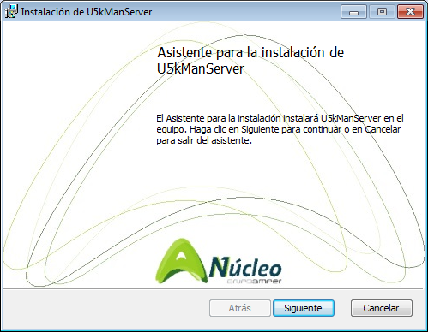

Figure 2. Server Installation. Presentation Screen.

* Type ’Siguiente’ (Next)…

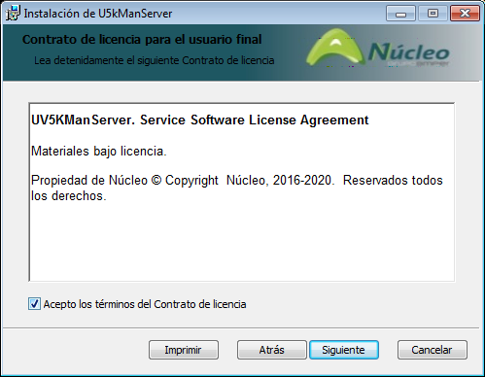

Figure 3. Server Installation. Accept Terms of the contract.

* Accept the terms and click ‘Siguiente’ (Next).

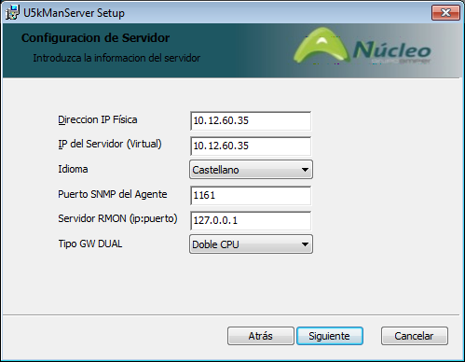

Figure 4. Server Installation. IP Configuration.

* Configure the IPs:
  + IP Address: Address of the machine.
  + Server IP. Address of the machine that contains the configuration service and database (Virtual IP in the case of machines in CLUSTERS).
  + Application language. The choices are Spanish, English or French.
  + Agent SNMP Port. In general, this is the standard port (161), but another value can be entered to ensure compatibility with other agents running on the machine.
  + RMON server (ip:port). Configures the ENDPOINT, where the RMON service will launch the TRAPS associated with the service quality variables. If the “port” field is not specified, the SNMP standard will be used (162).
* Click ‘Siguiente’ (Next).

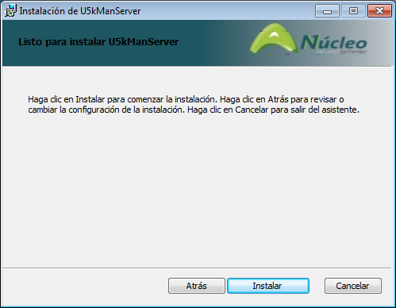

Figure 5. Server Installation. Confirm the Installation

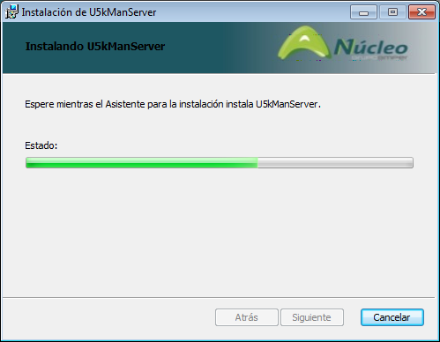

Figure 6. Server Installation. Installing the files and starting services.

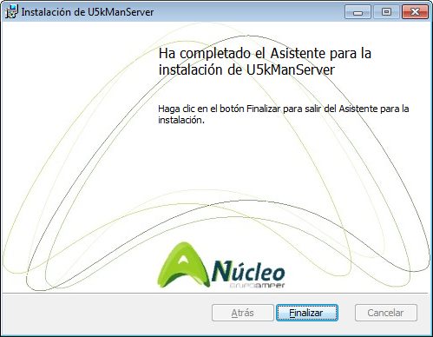

Figure 7. Server Installation. Installation completed.

## Configure the Application

Once the installation has been completed, the following page will be opened in the default web browser:

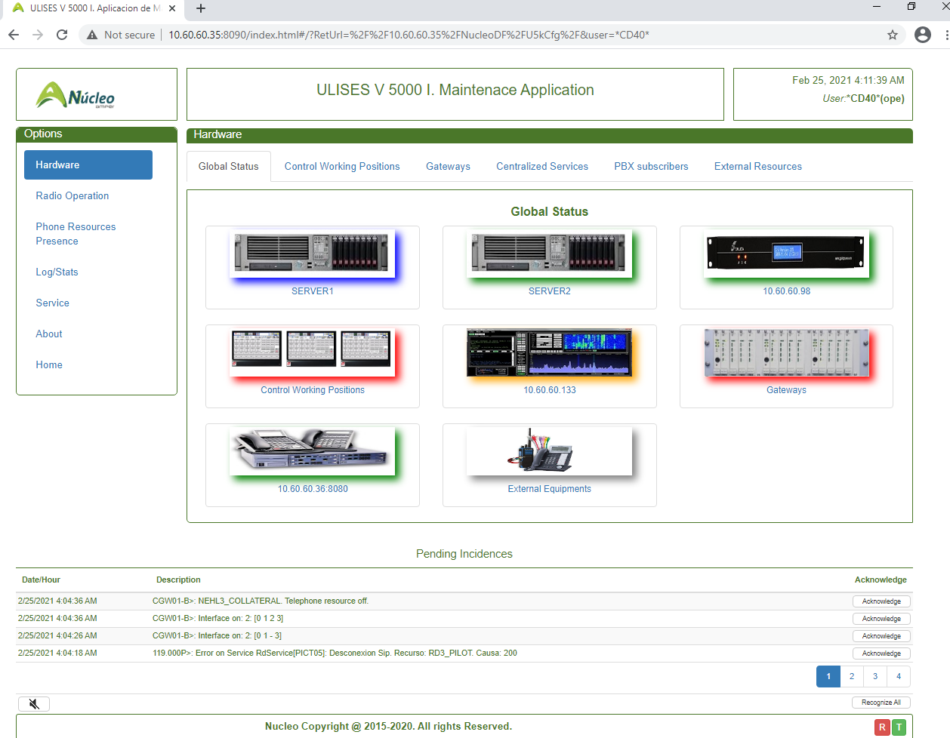

Figure 8. Server Installation. Maintenance Application.

Browse to Service + Service, and in the following page:

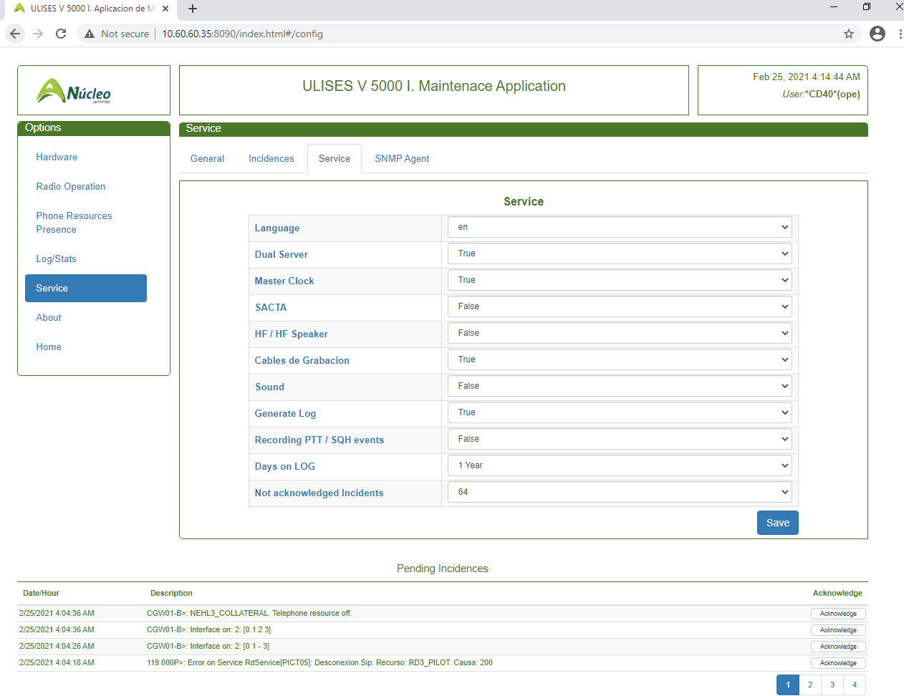

Figure 9. Server Installation. Configure the Application.

Configure the operational parameters of the server. This configuration can also be done at any time after the installation, as explained in 7.6.3.

# Usage requirements

## Recommendations prior to use

In order to ensure proper functioning of the application, we recommend that the following applications and versions be installed:

* Framework .NET 4.5.2
* Internet Explorer 11, Google Chrome or Mozilla Firefox.
* MySQL 5.6.
* Adobe Reader 8.

All of these products are supplied with the installation of the Configuration and Supervision application of the ULISES V 5000-I system, and they must all be installed before the application itself is installed.

# User Guide

This application is accessed through the ‘Maintenance’ links in the Configuration Pages, as described in the corresponding manual.

## Main Page

The home screen of the application is shown below:



Main Menu

Page information. Title

Header

Page information: Submenu

List of Incidents

Status of Subsystems

Acoustic Signal Control

Footer

Page information: Contents

Figure 10. Maintenance Application. Home Page.

### General Structure

As with all pages forming part of the application, this page has 6 different areas:

1. Header. Comprising:
   1. Logo and title of the application.
   2. Date and Time.
   3. Logged in User.
2. Main Menu. Located on the left side of the pages; does not vary throughout the application and provides access to:
   1. Hardware: Supervision of the system elements.
   2. Radio Operation: Displays the operational status of the radio subsystem.
   3. Phone Resources Presence: Displays the information on the presence of phone resources.
   4. Logs/Statistics. Management of Logs and Statistics.
   5. Service: Configuration and status of the application itself.
   6. About: Information on the application and legal information.
   7. Home: Return to the application (normally configuration) from which the call was made.
3. Information on the page. Located on the right, it contains three fields, which are, from top to bottom:
   1. Page title.
   2. Submenu. Depends on the main pages currently being displayed. It is made up of a series of tabs that provide access to the different information contained in the page.
   3. Graphic and/or text information corresponding to the current option or sub-option.
4. Alarm List. Only visible when there are alarms; provides a paginated display of the alarms in the system. The corresponding button to acknowledge the alarms is on the right, as well as access to acknowledgement of all of the alarms. The enable or disable acoustic warning control appears to the left if there are alarms pending to be acknowledged.
5. Application Footer. Two indicators appear to the right about the operating status of the radio and telephony subsystems:
   1. Radio Subsystem status indicator (“R”), which uses a colour code to establish the operating status of the radio subsystem:
      1. Alarm (Red). There are non-operational frequencies configured in the system.
      2. Warning (Orange). There are no NON-OPERATIONAL frequencies in the system, but some of them are in the “DEGRADED” mode.
      3. Normal (Green). All frequencies are operating correctly.
   2. Telephony Subsystem status indicator (“T”), which uses a colour code to establish the operating status of the telephony subsystem:
      1. No local PROXY (Red). No local proxy to transmit the system’s incoming and/or outgoing calls. The system’s internal incoming and outgoing calls are processed by the local elements (positions and gateways).
      2. With local alternative Proxy (Orange)[12]. The system’s main PROXY is unavailable. The system runs using an alternative proxy.
      3. Normal (Green). The system runs correctly with the main PROXY active.

### Alarm Management

The system shows a list of the events configured as alarms present in the system and not recognised by an operator. While there are events with this status, an acoustic signal may be generated for each event by using the control on the lower left of the list of alarms.

The procedure for acknowledging alarms is the following:

Individual Acknowledgement

A control will be displayed to the right of each alarm ITEM to acknowledge the alarm. When it is clicked, a confirmation message will be displayed to acknowledge the selected alarm, which will disappear from the list.

Acknowledge All

Under the list of pending Incidents, there is an Acknowledge All control that when clicked, after the corresponding confirmation message, will ‘acknowledge’ all of the alarms displayed at that time.

Acknowledgement records the time and the user who acknowledged the alarm in the corresponding logs.

The system maintains a limited number (See 7.6.3) of Unacknowledged alarms.

## Supervision Subsystem

The subsystem contains 6 different screens:

* Global Status.
* Control Working Positions Supervision.
* Gateways Supervision.
* Supervision of Centralized Services.
  + Radio Services.
  + Telephony Services.
* PBX Subscriber Supervision.
* External VOIP Resources Supervision.

The secondary menu of this subsystem provides access to the screens listed above.

### Display of Statuses

The statuses of the different elements that make up the supervision pages are shown on the graphic that corresponds to the element with a frame of mixed colours according to the following criteria:

|  |  |  |
| --- | --- | --- |
| Status | Criteria | Example |
| No Information | Graphic not faded with GREY border |  |
| Operational | Graphic not faded with GREEN border |  |
| Warning | Graphic not faded with ORANGE border |  |
| Alarm / Error | Graphic not faded with RED border |  |
| Standby[13] | Graphic not faded with BLUE border |  |

Table 6. Status Indicators

### Global Status Supervision Screen

Accessed through ‘Supervision’ + ‘Global Status’.

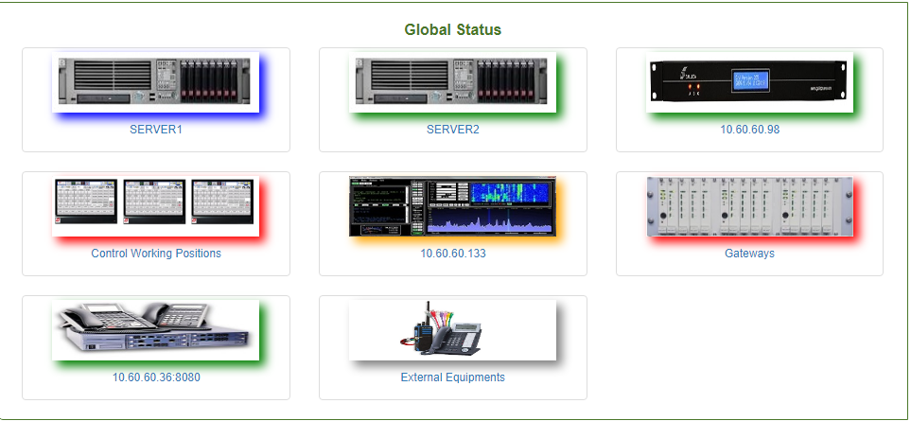

Figure 11. Maintenance Application. General Supervision Screen.

With the maximum configuration, the following information is displayed (from top to bottom and left to right):

* General Status of ‘Server 1’.
* General Status of ‘Server 2’, in the case of CLUSTER configurations.
* General Status of the Time Subsystem.
* General Status of Control Working Positions.
* General Status of Centralized Operator Services.
* General Status of Gateways.
* General Status of the Internal PABX.
* General Status of external VOIP Resources.
* General Status of the SACTA Subsystem (NETWORK1 and NETWORK2, if configured this way in the server).

#### General Status of Servers 1 and 2

The following information is displayed for each one:

* Graphic that identifies the Server, including its operational status, as described in 7.2.1. In the case of dual servers, when one server is operational and the other is not, the operational server will be indicated with a ‘WARNING’ status.
* Name or IP Address of the server. When this field is clicked, the CLUSTER management page of the Configuration Application will open.

#### General Status of the Time Subsystem (if configured on the server)

The following information is provided:

* Graphic that identifies the Service, including its operational status, as described in 7.2.1.



* Name or IP Address where the service is hosted.

#### General Status of the Operators Subsystem

The following information is provided:

* Graphic that identifies the Service, including its operational status, as described in 7.2.1.



* The criteria for representing statuses are the following:
  + No Information. No active operators.
  + Warning. There are present and not present Operators.
  + Alarm / Error. There are present operators that are reporting some type of error. The rest may be present or not present.
  + Correct. All resources are present and none are reporting an error.
* When the graphic that corresponds to this element is clicked, the application opens the operator supervision screen (7.2.3).

#### General Status of Centralized Operator Services

The following information is provided:

* Graphic that identifies the Service, including its operational status, as described in 7.2.1. The associated operating statuses are:
  + No Information. There is no operational element with the assigned centralized operator services.
  + Warning (orange outline). There is only one operational element with the assigned centralized operator services.
  + Operational (green outline). There are at least two operational elements with assigned centralized operator services (one master and one on standby).

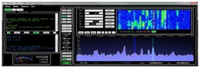

* + Error (red outline). There are no operational elements as MAIN or there are more than one with this function assigned.
* Name and IP address of the element where the centralized operator services are hosted in master mode. When the graphic that corresponds to this element is clicked, the application opens the centralized elements supervision screen (7.2.5).

#### General Status of the Gateways Subsystem

The following information is provided:

* Graphic that identifies the Service, including its operational status, as described in 7.2.1.

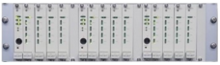

* The criteria for representing statuses are the following:
  + No Information. No active gateways.
  + Warning. There are present and not present gateways. The present gateways are not reporting errors.
  + Alarm / Error. There are present gateways that are reporting some type of error. The rest may be present or not present.
  + Correct. All gateways are present and none are reporting an error.
* When the graphic that corresponds to this element is clicked, the application opens the gateways supervision screen (7.2.3).

#### General Status of the Internal PBX (if configured on the server)

The following information is provided:

* Graphic that identifies the Service, including its operational status, as described in 7.2.1.

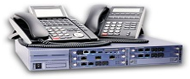

* Name or IP Address where the service is hosted. When the graphic that corresponds to this element is clicked, if it is operational, the web application opens the PBX status and configuration pages.

#### General Status of external VOIP Resources

* Graphic that identifies the Service, including its operational status, as described in 7.2.1.

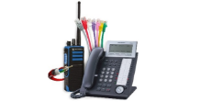

* The criteria for representing statuses are the following:
  + No Information. No active Resources.
  + Warning. There is an active Resource that is indicating a warning, or not all resources are present.
  + Alarm / Error. There are present resources that are reporting some type of error. The rest may be present or not present.
  + Correct. All resources are present and none are reporting an error.
* When the graphic that corresponds to this element is clicked, the application opens the operator supervision screen (7.2.3).

#### General Status of the SACTA Subsystem (if configured on the server)

The following information is provided:

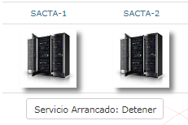

* For each one of the two possible SACTA networks:
  + Graphic that identifies the Service, including its operational status, as described in 7.2.1.
* SACTA service status control. Establishes whether the service is started or not, and provides the control to “stop” or “start” the service.

### CWP Supervision Screen

Corresponds to the screen displayed in Figure 12. It provides a graphic view of the status of the control working positions (CWP) configured in the system.

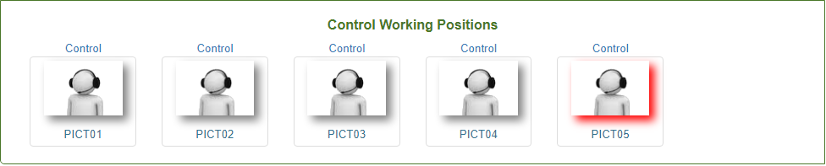

Figure 12. Maintenance Application. CWP Supervision.

This screen shows a list of the CWP configured in the system. For each operator, it displays:

* Graphic associated with Operator status. Uses the status codes described in 7.2.1.
* Name or identifier of the resource.
* When you click on the graphic for a position, a window will pop up with general information on the position in question:

|  |  |
| --- | --- |
| Status | Menu |
| Disconnected |  |
| Connected |  |

Table 7. Floating information for CWP.

### Gateways Supervision Screen

Provides a graphic view of the status of the gateways configured in the system.

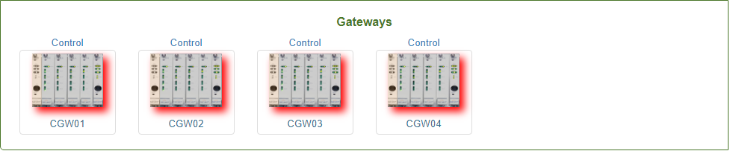

Figure 13. Maintenance Application. Gateways Supervision Screen.

Displays a list of the gateways configured in the system. The following information is displayed for each one:

* Gateway Access Control. Provides access to the gateway control menu, which depends on the type of gateway and its status:

|  |  |  |
| --- | --- | --- |
| Type | Status | Menu |
| Single | Disconnected |  |
|  | Connected |  |
| Dual (Mode 1 or 2) | Disconnected |  |
|  | Connected |  |

Table 8. Gateway control menu.

* Graphic that identifies the Service, including its operational status, as described in 7.2.1.

|  |  |
| --- | --- |
| Gateway Type | Graphic |
| Single |  |
| Dual Mode 1 (Only Dual CPUs) |  |
| Dual Mode 2 (Dual Physical Interfaces) |  |

Table 9. Gateway Graphics according to type

* Gateway identifier.

When you click on the graphic for a gateway, a window will pop up with general information on the gateway in question:

|  |  |  |
| --- | --- | --- |
| Status | Type | Menu |
| Disconnected | Single or Dual | Displays the IP configured for the gateway (Virtual IP for dual gateways). |
| Connected | Single | Displays the configured ID and the status of the two physical LANs available. |
|  | Dual | In addition to the configured IP and the LAN status, it provides information on the active CPU |

Table 10. Floating information for gateways.

#### Details of Single Gateways

When the ‘Details’ option is selected in the gateway control menu for a simple gateway, the detailed status information screen for the gateway will be displayed:

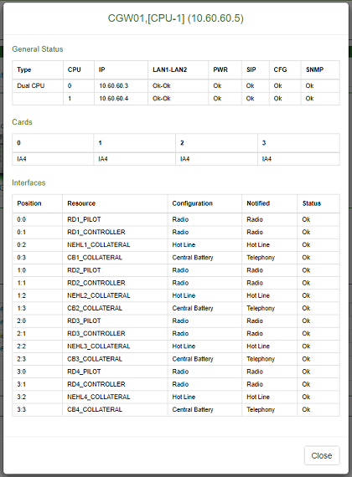

Figure 14. Maintenance Application. Details of a Single Gateway.

The information displayed on this screen is divided into 3 parts:

* General Information. This displays the gateway identifier and the associated IP address (access or virtual).
* General Status. The following information is displayed[14]:
  + Gateway Type. Simple, Dual CPU or Dual Interfaces.
  + CPU ID. In the case of single Gateways, this will always be ‘0’.
  + Physical IP of the CPU.
  + Status of LAN 1 and LAN 2. OK or FAIL.
  + Power Supply Status. OK or FAIL.
  + Status of the SIP Subsystem.
  + Status of the Configuration Subsystem.
  + Status of the Maintenance Subsystem.
* Status of Slave Cards. Displays the reported status of slave cards; for each one, it shows whether it is present and the reported type (only IA4 for now)[15].
* Interface Configuration and Status. List of 16 possible resources associated with the gateway by configuration. The following information is displayed for each one[16]:
  + Position: Resource Location, indicating the slave card and the interface within the card.
  + Resource. Name of the Resource, if it is configured in the database.
  + Configuration. Type of Resource according to the database configuration; resources may be of the following types:
    - Radio Interface
    - LCE Interface
    - AB Interface
    - CB Interface
    - LB Interface
    - R2 Interface
    - N5 Interface
    - Not Configured
    - Unknown
  + Resource notification. This is the configuration reported by the Hardware. The following configurations are reported:
    - No Information.
    - Radio Interface.
    - LCE Interface.
    - P2P Telephony Interface (AB, CB and LB).
    - ATS Telephony Interface (R2 and N5).
  + Resource Status. Indicates its operational status NORMAL, ERROR or NO INFORMATION. Theses statuses are reported by the internal SNMP manager, which determines which resources without an established SIP Session are in ERROR.

To close the window, press ESC or click on the ‘Close’ button.

#### Details of Dual Gateways

When the ‘Details’ option is selected in the gateway control menu for a dual gateway, the detailed status information screen for the gateway will be displayed:

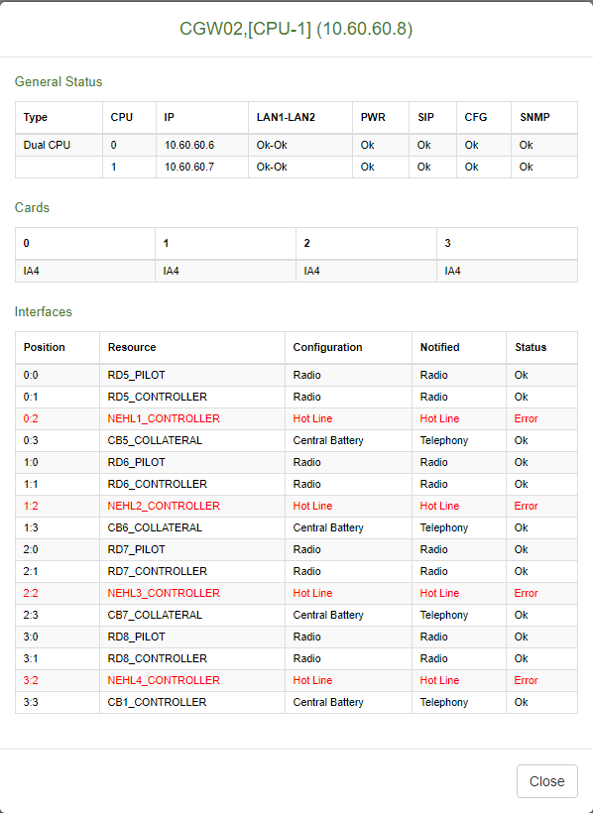

Figure 15. Maintenance Application. Details of a Dual Gateway.

The information displayed on this screen is similar to the one described in the previous point. The difference lies in the information associated with the general status and information:

* General Information. This displays the gateway identifier, the active CPU and the associated IP address (access or virtual).
* General Status. The following information is displayed:
  + Gateway Type. Simple, Dual CPU or Dual Interfaces.
  + Status of CPUs. For each CPU:
    - CPU ID.
    - Physical IP.
    - Status of LAN 1 and LAN 2. OK or FAIL.
  + Power Supply Status. OK or FAIL.
  + Status of the SIP Subsystem (on the active CPU).
  + Status of the configuration Subsystem (on the active CPU).
  + Status of the maintenance Subsystem (on the active CPU).

To close the window, press ESC or click on the ‘Close’ button.

#### Details of Software Version on Gateway

When the ‘Versions’ option in the control menu is clicked, in both single and dual configurations, a window (Figure 16) opens, displaying the version of each software module present on the gateway.

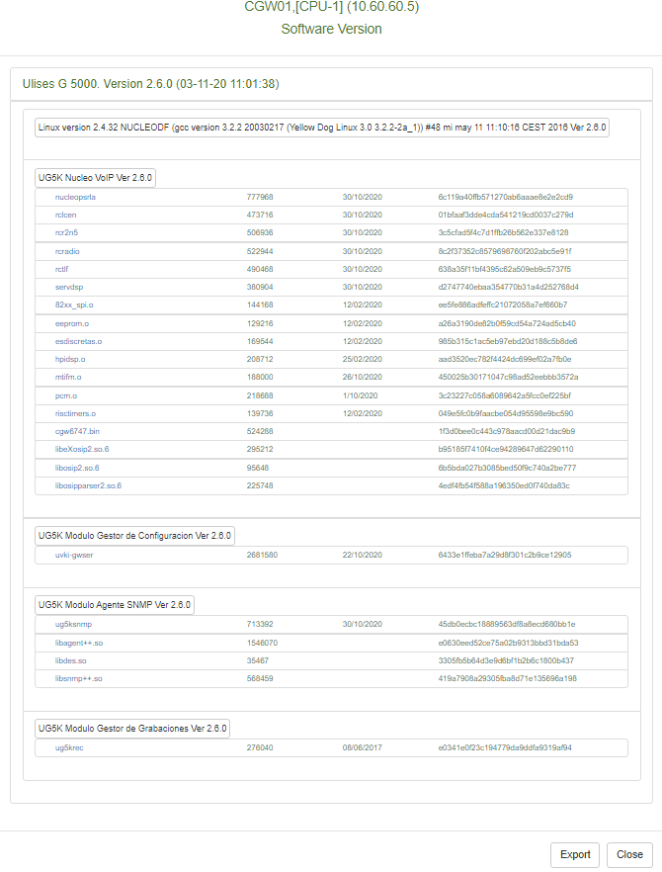

Figure 16. Maintenance Application. Gateway Software Version.

In this screen, the ‘Export’ button allows you to save the information to a comma-separated text file that can be consulted in EXCEL.

#### Status and Switching of CPU in Dual Gateways Method 1

The graphic that corresponds to this type of gateway (Figure 13), in addition to indicating the overall operational status of the gateway, also displays the operational status of each one of its CPUs, according to the table below:

|  |  |  |  |  |
| --- | --- | --- | --- | --- |
| Graphic | CPU-A | | CPU-B | |
|  | Status | Mode | Status | Mode |
|  | Not active |  | Not active |  |
|  | Not active |  | Active | Main |
|  | Not active |  | Active | Standby |
|  | Active | Main | Not active |  |
|  | Active | Standby | Not active |  |
|  | Active | Main | Active | Standby |
|  | Active | Standby | Active | Main |
|  | Active | Standby | Active | Standby |
|  | Active | Main | Active | Main |

#### Status and Switching of CPU in Dual Gateways Mode 2

When the option ‘M/S Switch’ is clicked in the control menu, in dual configurations, and after confirmation in an additional dialogue, the switchover command will be sent to the corresponding gateway. The execution of this command appears when the general status of the gateway is obtained, as described in 7.2.3 and 7.2.4.2.

### Centralized Services Supervision Screen

Corresponds to the screen displayed in Figure 17. It provides a graphic view of the status of the elements with centralized services in the system.

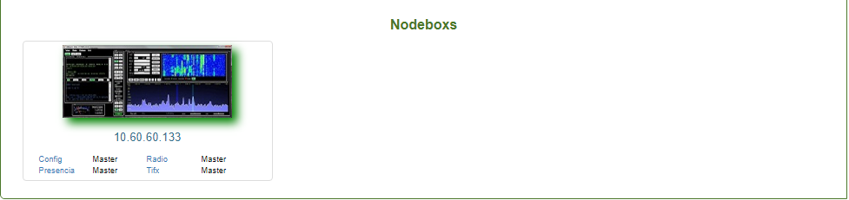

Figure 17. Maintenance Application. Supervision of Centralized Services.

Each one of these elements shows its overall status (active or standby) by the colour of the outline:

* Green: Active.
* Orange: Standby.

It also gives the operator the following information about the element:

* Location, through the element’s IP address.
* Service Status:
  + CFG. Operator configuration management service.
  + Radio. Radio session management service.
  + TIFX. Service to manage presence of interfaces and internal telephone subscribers.
  + Presence. Service to manage presence of PROXIES and external ATS telephone subscribers.

These services may have one of the following statuses[17]:

* Master. The service is functioning and activated.
* Slave. The service is functioning and on standby.
* Stopped. The service is not functioning.

When you click on the corresponding graphic for a particular element, a browser tab opens with the status and configuration pages of the centralized operator services. See Annex A. Centralized Services Supervision Screens.

### PBX Subscriber Supervision Screen

Corresponds to the screen displayed in Figure 18. It provides a graphic view of the status of the PBX subscribers configured in the system.

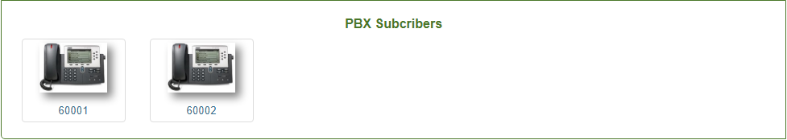

Figure 18. Maintenance Application. PBX Subscriber Supervision.

This page provides the following information for each operator terminal:

* Graphic. Indicates the connection status of the element according to the following criteria:

|  |  |
| --- | --- |
|  | Terminal Registered. |
|  | Terminal Not Registered. |

* Subscriber ID.

### Screen for Supervision of Resources on External VoIP Units

The maintenance system supervises RESOURCES associated with EXTERNAL UNITS. It supervises IP connectivity of the external unit, as well as the presence of the SIP Agent associated with the resource[18]. Depending on this criterion, resources may have one of the following statuses:

1. Resource Disconnected. The external unit does not respond to the PINGs at the IP configured for it.
2. Resource connected and in ERROR. The external unit responds to PINGs but the SIP Agent associated with the resource does not.
3. Resource connected and in WARNING. The unit is connected at the IP level, with a SIP AGENT that responds, but it does not properly complete the poll procedure (SIP OPTIONS).
4. Resource connected and SIP agent responding correctly.

The screen shown in Figure 19 provides a graphic view of the status of the resources on external units (radio, telephony or recorders) configured in the system.

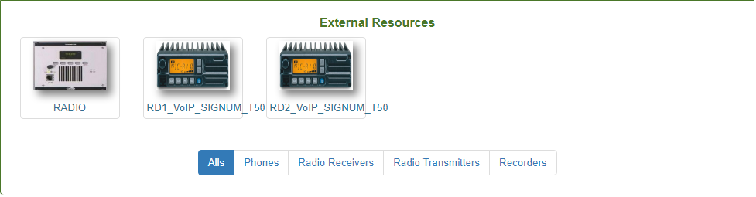

Figure 19. Maintenance Application. Supervision of External Units.

This page provides the following information for each operator terminal:

* Graphic. It shows the type of external unit and the connection status of the resource based on the following criteria:

|  |  |
| --- | --- |
|  | Telephony Resource Active |
|  | Telephony Resource in Warning |
|  | Telephony Resource in Alarm |
|  | Telephony Resource Not Active |
|  | Radio Resource Active[19] |
|  | Radio Resource in Warning |
|  | Radio Resource in Alarm |
|  | Radio Resource Not Active |
|  | Recorder Resource Not Active |
|  | Recorder Resource Active |

* Unit Identifier.

The program allows you to filter the display with the controls at the bottom, according to:

* ‘All’: Displays all of the external units (Radio and Telephony).
* ‘Phones’: Displays all of the external telephone units.
* ‘Radio Receivers’: Displays the external radio units that are receivers.
* ‘Radio Transmitters’: Displays the external radio units that are transmitters.
* ‘Recorders’: Displays the external recorder units.

## RADIO Operation Subsystem

It is shown in the following screen:

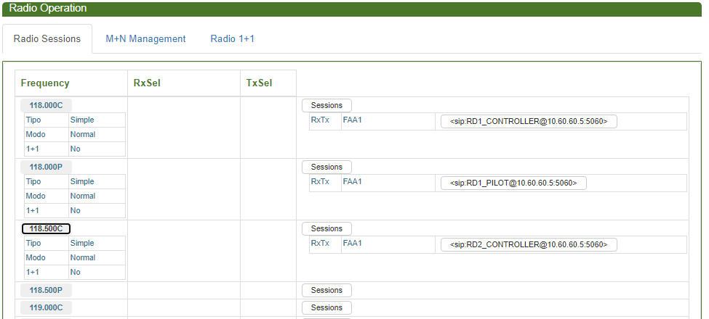

Figure 20. Radio Operation Subsystem.

The subsystem contains 4 different screens:

* Display of Radio Sessions.
* Display of M+N management module.
* Display of 1+1 management module.
* Display of HF transmitter status module.

The secondary menu of this subsystem provides access to the screens listed above.

### Radio Sessions

This screen displays the radio sessions maintained in the system. The information is displayed on the following screen:

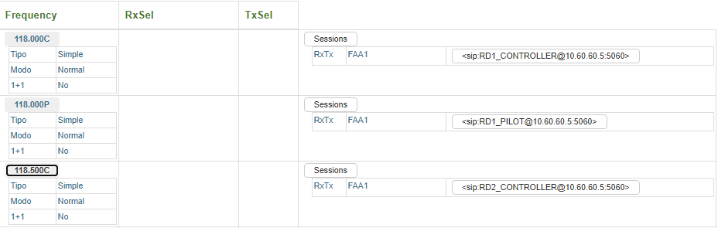

Data related to Frequency

Sessions List

Frequencies List

Figure 21. Radio Sessions.

This screen displays a list of radio sessions maintained by the system, grouped by frequency. The first level of the list (Frequencies) is made up of one entry for each Frequency (Radio Destinations) configured and assigned in the system.

The colours of the Background and text indicate the operational status of the frequency: RED text on a YELLOW background indicates that there is a problem in the Frequency, and BLUE text on a WHITE background indicates that the frequency is operating correctly (at the SIP level). The following fields are displayed for each frequency (from left to right):

* Frequency ID. Click on this field to open a drop-down menu with the data associated with the frequency:
  + Frequency Type (single or in multiple sites)
  + Session priority (Normal, Emergency)
  + Presence of 1+1 elements.
  + TX mode (CLIMAX or BTS, only for Frequencies in multiple sites)
  + CLIMAX mode (Absolute or Relative, only in frequencies in the TX CLIMAX mode).
  + BSS method selected (RSSI, NUCLEO-RSSI, only in the case of multiple frequencies or simple frequencies with the presence of 1+1 elements).
  + BSS Window (expressed in milliseconds, only in the case of multiple frequencies or in single frequencies with the presence of 1+1 elements).
* Reception element selected (RxSel). It shows the site, the selected receiver ID and the qualification index of the audio signal received during reception.
* Transmission site selected (TxSel). It marks the selected transmission mode in multi-site frequencies (OC):
  + CLX. CLIMAX mode
  + Selected site, according to the last aircraft reception received.
* Display control for sessions that make up the Frequency. When this control is clicked, the SIP sessions that make up the frequency are displayed. The colour of the background and text indicate the operational status of the session: RED text on a YELLOW background indicates that the session is disconnected, and BLUE text on a WHITE background indicates that the session is connected (at the SIP level). The following information is displayed for each Session:
  + Session Type (Rx: Reception, Tx: Transmission, RxTx: Two-way).
  + Site associated with the resource.
  + URI associated with the session. Click on this element to open a drop-down menu with the parameters associated with the session. These parameters are as follows:
    - RTPTx. RTP Tx Port associated with the session (In Tx and RxTx types).
    - CLD. CLD calculated for the Session (in Tx and RxTx types).
    - OWD. OWD calculated for the Session (in Tx and RxTx types).
    - RTPRx. RTP Rx Port associated with the session (In Rx and RxTx types).
    - QIDX. Audio qualification value associated with the session (In Rx and RxTx types).

### M+N Manager

This section shows the operating status of the M+N manager. It will only be displayed for the installations that have these types of elements. It looks like this:

Site Units

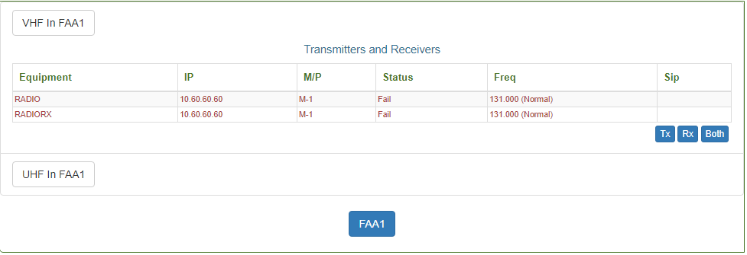

Display Control of UHF Units in Site

Site Control

Site Units Filter

Display Control of VHF Units in Site

Figure 22. M+N Manager

This screen is organized into 3 sections:

1. Units in VHF Band at Site. Made up of a Display control which displays or hides the list of units when activated and a unit’s filter that allows you to select transmitters only, receivers only, or both.
2. Units in UHF Band at Site. This is a section that is identical to the previous one, except that it refers to units in the UHF band.
3. Site Control. Shows the different sites with managed M+N units. Clicking on these controls ‘changes’ the site displayed in the previous 2 sections.

The following information is displayed for each element in the lists of sections 1 and 2:

* Equipment. Identifier of the radio resource associated with the unit.
* IP. IP Address of the radio unit.
* M/P. Shows whether the radio unit is Main (M) or Standby (S) and the relative Priority assigned to the frequency that provides support on the main units.
* Status. Status of the unit for the manager. It can take the following values:
  + Fail. Unit not available due to a fault that is detected or reported on the management interface.
  + Assigned. Unit available and assigned to a frequency.
  + Available. Unit available to be assigned to a frequency.
  + Disabled. Unit not available by manual decision.
* Freq. Operating Frequency (in Mhz) of the MAIN and STANDBY units assigned. The field will be blank for “Unassigned” STANDBY units. The priority of the session configured for the unit is displayed in brackets: Normal or Emergency.
* Sip. Associated SIP session. It can take the following values:
  + Blank. The unit does not have a SIP session configured (and should not have one).
  + No. The unit should have an associated SIP session but does not.
  + Disc. The unit has an associated SIP session in the system but it is not connected.
  + Conn. The unit has an associated SIP session in the system and is connected.

### 1+1 Manager

This section shows the operating status of the 1+1 equipment control subsystem’s elements. It will only be visible for the installations that contain these types of elements.

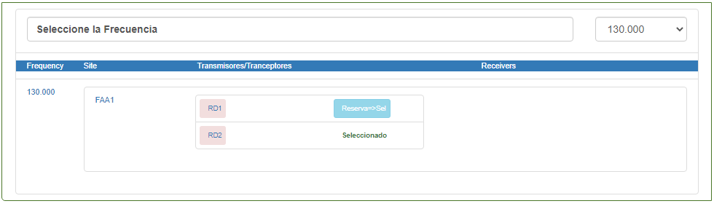

Transmitters in 1+1

Receivers in 1+1

Site

Selected Frequency

Frequency Selector

Figure 23. 1+1 Manager.

The data in this section is divided into 2 parts:

* Frequency selection control with 1+1 elements. Located on the top, used to select the frequency (with 1+1 elements) to display.
* Composition of 1+1 elements of the selected frequency. Displayed in the form of a drop-down list with the following elements:
  + Frequency Identifier.
  + Site in which this frequency has 1+1 elements.
  + Transmitters/Transceivers in 1+1 (at the indicated site). For each one of them:
    - Resource identifier.
    - Operating status. Through the background colour.
    - Selection status. Main or Standby. In the resources set to Standby, the control is presented to force manual switch of the elements; prior authorisation will be requested.
  + Receivers in 1+1. The following information is displayed for each one of them:
    - Receiver ID.
    - Operating status. Through the background colour. This status also includes the “disabled” status.
    - Control to Enable/Disable an element of the reception group.

### Assignment Status of HF Transmitters

This section displays the operational status of the HF radio Transmitter Assignment manager. It will only be visible for the installations that contain these types of elements. It looks like this:

_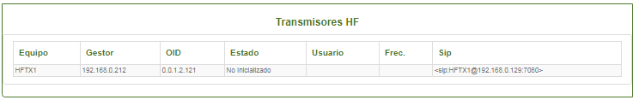

Site Units

Figure 24. HF radio Transmitter Assignment Manager.

The following information is displayed for each element in the list:

* **Equipment**. Identifier of the radio resource associated with the HF transmitter.
* **Manager.** IP address of the SNMP manager associated with the Remote-control subsystem.
* **OID.** SNMP base address in the manager associated with the HF transmitter unit.
* **Status**. Indicates the availability of the unit in the HF management subsystem. It can take the following values:
  + Not Initialized.
  + Available.
  + Assigned.
  + Fail.
  + Disabled.
* **User.** Indicates the operator, who in such case (Assigned) has the Transmitter occupied.
* **Freq**. Indicates the frequency to which in such case (Assigned) the unit is tuned.
* **SIP**. URI associated with the radio resource.

## Telephone Resource Presence Subsystem

It is shown in the following screen:

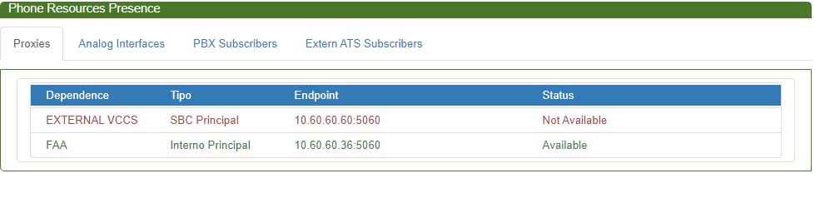

Figure 25. Telephone Resource Presence Subsystem.

The subsystem contains 4 different screens:

* Display of Proxy Availability.
* Display of Analogue Interface Availability.
* Display of Availability of SIP Subscribers in the internal PBX.
* Display of Availability of external ATS/SIP Subscribers.

The secondary menu of this subsystem provides access to the screens listed above.

### Proxy Availability

This screen displays the availability status of the SIP Proxy elements configured in the system. The information is displayed on the following screen:

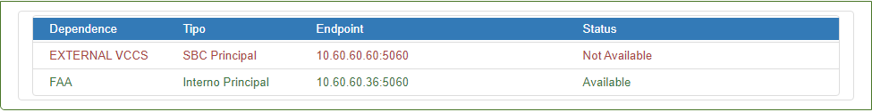

Figure 26. SIP Proxy Availability.

This screen shows a list of the external SIP PROXY elements that have been configured in the system. The following information is displayed for each element:

* Dependence: Identifier of the dependence to which the element corresponds.
* Type: Identifies the role adopted by the element in the SIP management of the dependence to which it belongs. The defined roles or types are the following:
  + Local-Main. This refers to the PROXY of the dependence that is configured as the main or default proxy.
  + Local-Alternative. This refers to the PROXIES of the dependence that are configured as alternative to the main or default proxy.
  + External-Main. This refers to the PROXIES of the external dependences that are configured as main or default proxy for the dependence.
  + External-Alternative. This refers to the PROXIES of the external dependences that are configured as alternative to the main or default proxy for the dependence.
* Endpoint: Refers to the IP / Port pair where the service of the referenced SIP PROXY is located.
* Status: Indicates the connectivity status for system presence agent for the selected element. The possible statuses are:
  + Available. The element responds to the poll that the agent carries out. In this status, the text is displayed in GREEN.
  + Not Available. The element DOES NOT RESPOND to the poll that the agent carries out. In this status, the text is displayed in RED.

### Availability of Analogue Interfaces

This screen displays the availability status of the analogue telephone interfaces configured in the system. The information is displayed on the following screen:

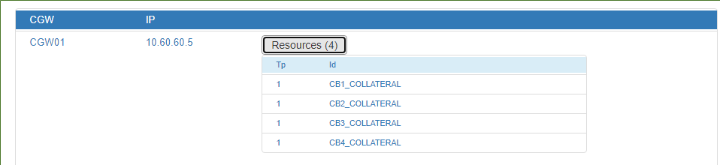

Figure 27. Availability of Analogue interfaces

The information on this screen is organised into two levels.

The first level displays a list of GATEWAYS that are notifying the presence agent of the availability of its analogue interfaces. The system displays the following information for each one of these units:

* Gateway Identifier.
* IP Address associated with the gateway.
* Number of interfaces (Resources) notified[20]. When this control is clicked, it opens the second level of information, which refers to the notified interfaces. The following information is displayed for each one:
  + Interface Type. LEGACY telephony interfaces (LB/CB/BA/R2/N5) may take the value ‘1’, with the value ‘2’ used for NEHL interfaces.
  + Interface identifier.

### Subscriber Availability in Internal PBX

This screen displays the availability status of the internal subscribers[21] registered in the PBX (LOCAL PROXY) in the system. The information is displayed on the following screen:

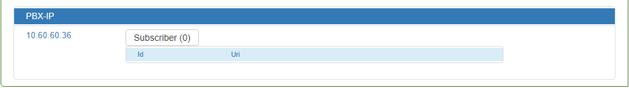

Figure 28. PBX Subscriber Availability.

This screen displays a list of the subscribers configured and registered in the local PBX. The following information is displayed for each one of them:

* Resource identifier.
* The assigned SIP URI.

### Availability of External ATS-SIP Subscribers

This screen displays the availability status of the external ATS-SIP destinations that have been configured in the system. The information is displayed on the following screen:

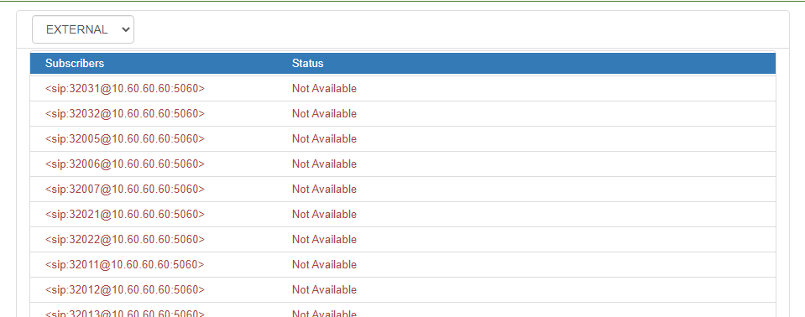

Figure 29. Availability of External ATS-SIP Destinations.

This screen shows a list of the external ATS-SIP destinations that have been configured in the system.

The first element is a dependence filter, whose subscribers are to be monitored. It consists of a dropdown window with the different configured dependences. When one is selected, a list drops down with the subscribers of the dependence in question. The following information is displayed for each element:

* Subscriber: Indicates the presence URI (with which it would be registered in the presence service of the dependence in question).
* Status: Indicates the connectivity status for system presence agent[22] for the selected element. The possible statuses are:
  + Available. In this status, the text is displayed in GREEN.
  + Not Available. In this status, the text is displayed in RED.

## Log/Statistics Subsystem

The subsystem contains 2 different screens:

* Log Manager.
* Statistics Manager.

The secondary menu of this subsystem provides access to the screens listed above.

### Log Manager

This screen provides the tools that are needed to use the information contained in the system’s incident log.

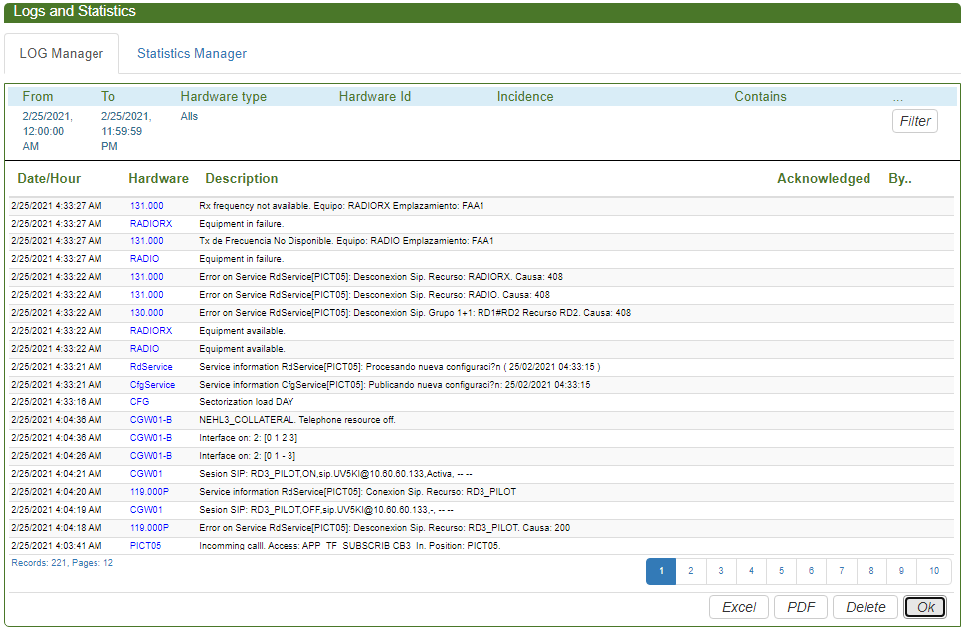

Figure 30. Maintenance Application. Log screen.

This page is divided into two parts:

**Display Filter.** Located at the top of the screen, it displays the log filter that is established. The ‘Filter’ option opens the filter configuration screen:

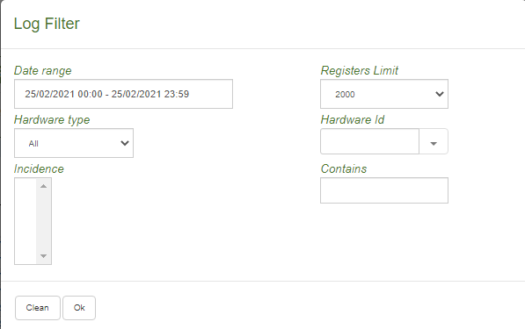

Figure 31. Maintenance Application. Configuration of Log Filter.

This screen is used to set the selection criteria to query the log file. These criteria may be:

* **Date/Time Range.** Select the start date/time and the end date/time when the events occurred.
* **Registers Limit.** Sets the maximum length of records that will be returned by the query.
* **Hardware type.** Select the group of logs for which you want to obtain the records. The possible values are:
  + General.
  + Operators.
  + Gateways.
  + HF Radio.
  + M+N Radio.
  + External Units.
* **Hardware Id.** If a specific Hardware type has been selected, in *Hardware Id*, you can select the specific element for which you would like to obtain the logs. If it is not a closed set of elements, the system allows you to enter a text string in this field.
* **Incident.** Select one or more incidents to consult, in the groups defined previously.
* **Contains.** Select a text or texts that must be present in the ‘DESCRIPTION’ field of the log record. To select records with more than one text, enter them separated by a semi-colon.
* **Controls.**
  + Clean. Clears the selected filter.
  + Ok. Validates the selected filter.

**Query Display** It consists of a paginated list of the events[23] from the log file that you have selected with the Display Filter. This list is displayed in order from most recent to less recent, and it includes the following fields for each event:

* **Date/Hour.** Date/Time when the event occurred.
* **Hardware.** Identifier associated with the unit that generated the event.
* **Description.** Literal associated with and explaining the event.
* **Acknowledged**. Date and time of acknowledgement of the event, if configured this way.
* **By:** The user who acknowledged the alarm.

The previous list is paginated. Pagination controls are displayed at the bottom, allowing you to move to different pages of the query.

The general procedure for using this tool is as follows:

* Configure the display filter.
* Click the “Ok” control. The list of incidents that meet the configured criteria will be filled in.
* If the number of incidents exceeds the number in one page, the list offers navigation controls to move between pages.
* After the incidents have been selected, you can generate a report in PDF or Excel (CSV text) format with the incidents. To do this:
  + Click the “PDF” or “Excel” control at the bottom.
  + The system will ask you to save the corresponding file.
  + After the file has been saved, you can open it with any PDF / Excel reader.
* The ‘Delete’ control clears the list to allow you to make another query.

### Statistics Manager

This screen provides the tools that are needed to make the statistical calculations contained in the system’s registry.

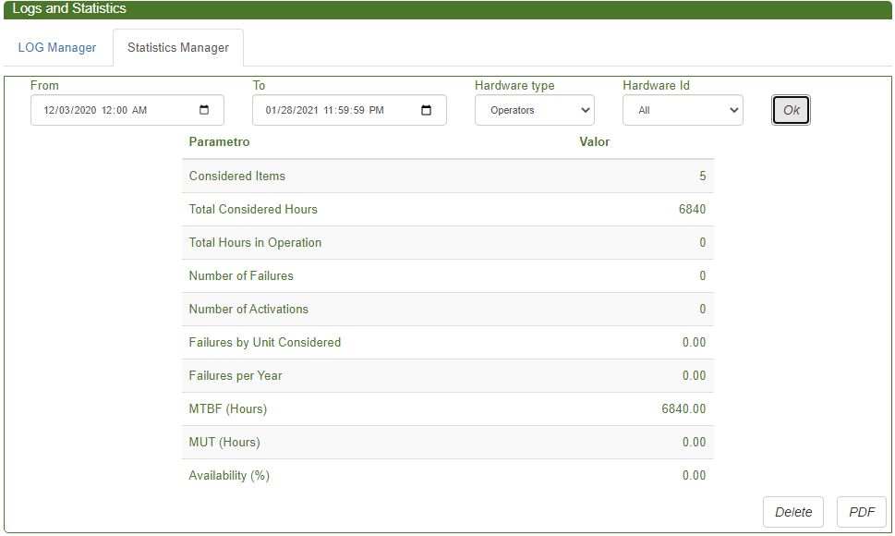

Figure 32. Maintenance Application. Statistics Screen

This page is divided into two parts:

**Display Filter.** This screen is used to set the selection criteria to query the system registry. These criteria may be:

* **Dates from. Date to.** Select the dates when the events occurred.
* **Hardware type.** Select the type of hardware element for which you want to obtain the statistical calculations. The possible values are:
  + Operators.
  + Gateways.
  + IP Radios
  + IP Telephone units
  + IP Recorders
* **Hardware ID.** If a specific Hardware type has been selected, in *Hardware ID*, you can select the specific element for which you would like to obtain the logs.

**Statistics Display.** Shows the following information and calculated parameters:

* **Considered items (NU)**. Number of Operators or Gateways for which the calculation is being carried out.
* **Total Considered Hours (TH)**. Total Hours. Result of the operation ((FROM-TO)*NU);
* **Total Hours in Operation (TO).** Total hours of operation recorded in the system for all of the units or items considered.
* **Number of Failures (NF)**. Number of Incidents (downtime) recorded in the interval for all of the units or items considered.
* **Number of Activations** (NA). Number of Incidents (active) recorded in the interval for all of the units or items considered.
* **Failures by Unit Considered.** Result of the operation NF/NU.
* **Failures per Year.** Result of the operation ((NF * (365 * 24)) / (TH/NU)).
* **MTBF (in hours)**. Mean time between failures. Result of the operation (TH / NF). If NF is zero MTBF = TH.
* **MUT (in hours)**. Mean time of unit in operational status. Result of the operation (TO / NA). If NA is zero MUT = TO.
* **Availability (in %)**. Result of the operation ((TO / TH) * 100).

The general procedure for using this tool is as follows:

* The filter is configured, clicking on the controls related to each criterion.
* Click the “Ok” control. The data and calculations carried out are displayed.
* After the calculations have been carried out, you can generate a report in PDF format. To do this:
  + Click the “PDF” control at the bottom.
  + The system will ask you to save the corresponding file.
  + After the file has been saved, you can open it with any PDF reader.
* The ‘Delete’ control clears the calculation to allow you to carry out a new one.

## Service Subsystem

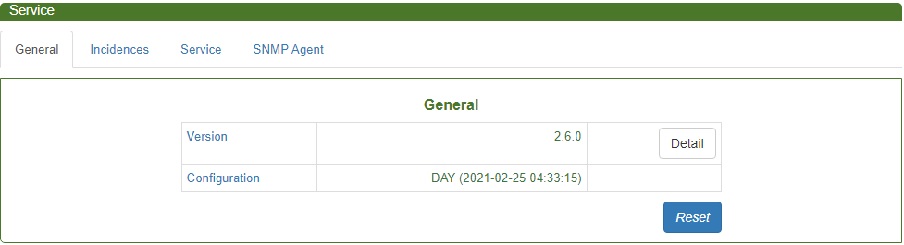

Figure 33. Maintenance Application. Service Subsystem

The subsystem contains 4 different screens:

* General.
* Incidents.
* Service.
* SNMP Agent.
* Configuration of the SACTA Service. Only appears when SACTA is configured in the system.

The secondary menu of this subsystem provides access to the screens listed above.

### General Information



Figure 34. Maintenance Application. General Information.

This screen displays the following information:

* Version of the software that is running on the server.
* Configuration, identification of the database configuration that is being used.

It also offers two controls for maintenance users:

* Reset. Allows the service to be RESTARTED. This operation is done after an additional confirmation.

### Configuration of Incidents

This screen is used to configure the incidents that should generate alarm events and those that should not.

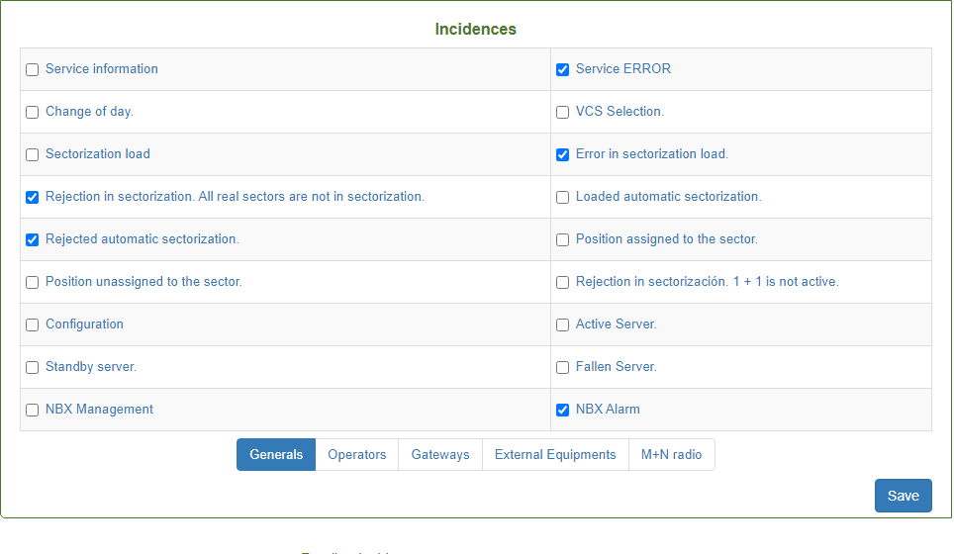

Figure 35. Maintenance Application. Incidents Configuration.

Incidents are organized into 6 groups (Figure 35):

* General Incidents.
* Incidents Associated with Operators.
* Incidents Associated with Gateways.
* Incidents Associated with External VoIP Units.
* Incidents Associated with the Management of HF Transmitters.
* Incidents Associated with the Management of M+N Radio.

The application displays the incidents from each group by clicking on the controls at the bottom.

To the left of each incident of each group there is a checkbox. If the box is marked, it means that the corresponding incident is configured as an alarm. When these controls are clicked, the incident is activated or deactivated as an alarm.

The ‘Save’ control consolidates the changes in the database and reboots the server. For this reason, additional confirmation is requested.

### Service Configuration

This screen (Figure 36) allows you to configure several operational parameters of the maintenance service.

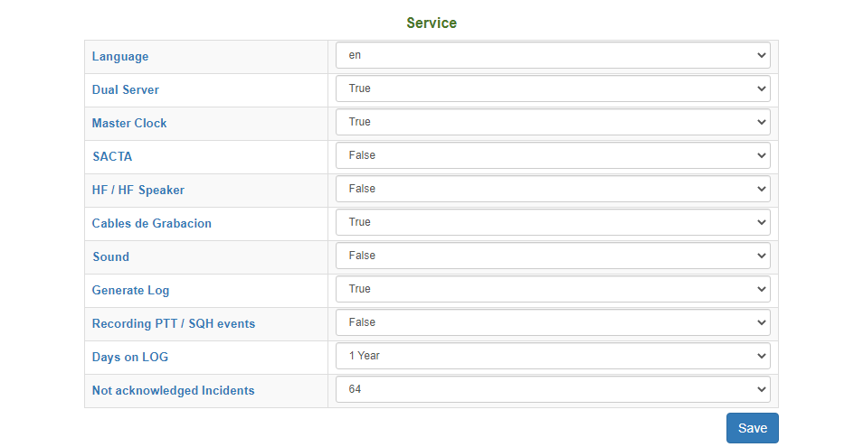

Figure 36. Maintenance Application. Server Configuration.

This screen allows you to change the following operational parameters:

* **Language.** You can choose between Spanish (es), English (en) and French (fr).
* **Dual Server.** Can take the values TRUE (the server is dual) or FALSE (the server is not dual).
* **Master Clock**. Can take the values TRUE (there is a master clock) or FALSE (there is no master clock).
* **SACTA**. Can take the values TRUE (the system manages an interface to SACTA) or FALSE (the system does not manage an interface to SACTA).
* **HF / HF Speaker.** Can take the values TRUE (the system supports HF management) or FALSE (the system does not support HF management).
* **Recording Cables**. Can take the values TRUE (the system supervises the presence of analogue recording cables at the positions) or FALSE (the system does not supervise them).
* **Sound**. Can take the values TRUE (the server generates an acoustic alarm when there are unacknowledged alarms) or FALSE (the system does not generate acoustic alarms).
* **Generate Log**. Can take the values TRUE (the system generates an Incident Log) or FALSE (the system does not generate a log).
* **Recording PTT/SQH Events**. Activates or Deactivates the storage of this type of event in the Database.
* **Days on Log.** Specifies the depths of the log that is maintained in the database. You can select from 1 Week, 2 Weeks, 1 Month, 3 Months, 6 Months or 1 Year.
* **Not acknowledged incidents.** Indicates the maximum number of unacknowledged events that the system maintains (provided that they are the most recent ones). The possible values are 8, 16, 32 and 64.

The ‘Save’ control consolidates the changes in the database and reboots the server. For this reason, additional confirmation is requested.

### SNMP Agent

This screen allows you to configure the operational parameters of the SNMP Agent included in the service.

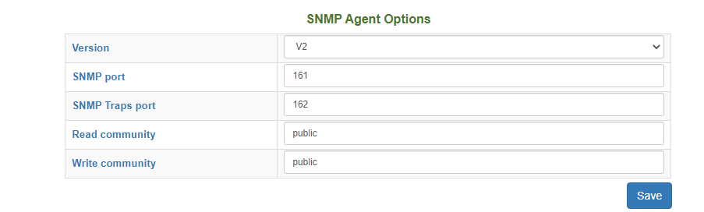

Figure 37. Maintenance Application. SNMP Options.

This screen allows you to select the following operational parameters.

* **Version**. This option allows you to select the version of the protocol under which the agent will operate. You can select between ‘V2’[24] (includes V1 and V2 of SNMP) and ‘V3’, for version 3 of SNMP.
* **SNMP Port**. UDP port associated with the service. By default, 161.
* **SNMP TRAPS port**. UDP port listening for TRAPS events from the rest of the system.

Depending on the selected version of the protocol, the system allows the following fields to be configured:

**Version-2**.

* Read Community.
* Write Community.

**Version-3**. The users and profiles that have access to the service can be configured.

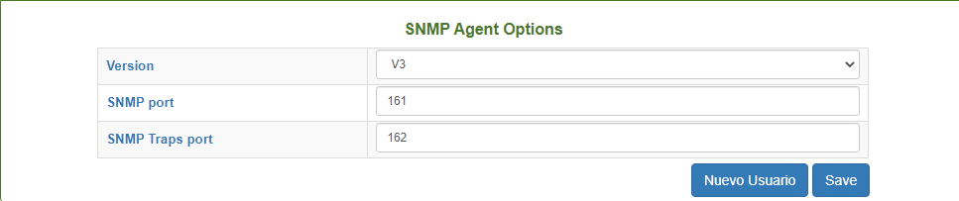

Figure 38. Maintenance Application. SNMP V3 Options.

The following parameters can be configured for each user:

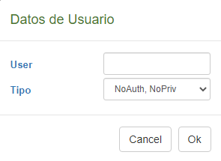

Figure 39. Maintenance Application. SNMP V3 User.

* **User.** User identifier.
* **Type**. You can choose between the following types of Users:
  + **No Auth, No Priv**. User with no authentication or privacy.
  + **Auth, No Priv**. User that must identify himself[25].
  + **Auth, Priv**. User that must identify himself and data exchanges will be encrypted[26].
* **PWD-AUTH**. Key to generate the authentication HASH.
* **PWD-PRIV**. Data encryption key.

The tools available for managing users will allow you to do the following:

* **New User.** Allows you to add a user to the manager.
* **Mod**. Allows you to modify the selected user.
* **Del**. Allows you to delete the selected user.

The ‘Save’ control consolidates the changes in the database and reboots the server. For this reason, additional confirmation is requested.

### Configuration of the SACTA Interface Service

This screen allows you to configure several operational parameters of the SACTA interface service.

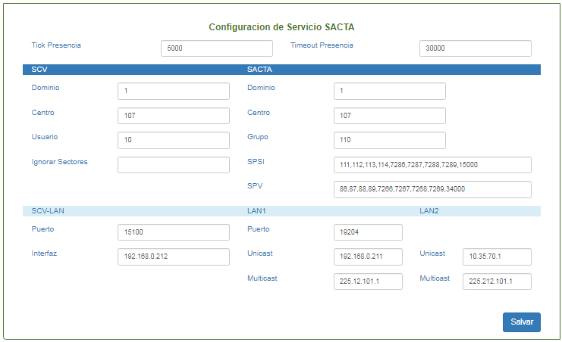

Figure 40. Maintenance Application. Configuration of the SACTA Interface Service.

This screen allows you to change the following operational parameters:

1. **General Parameters:**
   1. Presence Tick. Time in milliseconds of the SACTA presence poll.
   2. Presence Timeout. Time in milliseconds, after which, without receiving a presence notification, the service determines that SACTA has disappeared from the network.
2. **Configuration of the SACTA Protocol:**
   1. ***Parameters in VCS.***
      1. Domain. Used in the message headers, in the origin domain and destination domain fields. It can take the following values: (1) = OPERATIONAL or (2) = SIMULATION. In any case, this must be the same as the value configured for the SACTA.
      2. Centre. Used in the message headers, in the origin centre and destination centre fields. It is defined in the SACTA documentation and must be provided by ENAIRE for each installation.
      3. User. Identification number of the user. Used in the message headers, in the origin user and destination user fields. It is defined in the SACTA documentation and must be provided by ENAIRE for each installation.
      4. Ignore Sectors. List of Ids of Sectors (numbers separated by commas) that should be ignored when processing the messages received from SACTA. They normally correspond to VCS sectors, grouped by SACTA criteria to the VCS that is to be sectorized.
   2. ***SACTA Parameters****.*
      1. Domain. Used in the message headers, in the origin domain and destination domain fields. It can take the following values: (1) = OPERATIONAL or (2) = SIMULATION. In any case, this must be the same as the value configured for the VCS.
      2. Centre. Used in the message headers, in the origin centre and destination centre fields. It is defined in the SACTA documentation and must be provided by ENAIRE for each installation.
      3. Group. Identifier of the PSI Group, defined by SACTA criteria, where the multicast messages generated by the VCS should be addressed. This must be provided by ENAIRE for each installation.
      4. SPSI. List of identifiers (numbers separated by commas), defined by SACTA criteria, that identify users of sectorization messages. This must be provided by ENAIRE for each installation.
      5. SPV. List of identifiers (numbers separated by commas), defined by SACTA criteria, that identify users of presence messages and sequence start. This must be provided by ENAIRE for each installation.
3. **Network Configuration for SACTA**.
   1. ***Parameters in VCS.***
      1. Port. UDP Port where the VCS listens for SACTA requests. The preset value of this port for SACTA is 19204.
      2. Interface. IP address where SACTA UNICAST requests are sent. Must correspond to the Virtual IP of the VCS Server.
   2. ***Parameters on SACTA Networks***
      1. LAN1.
         1. Port. UDP Port where the SACTA service listens for VCS notifications. The preset value of this port for SACTA is 15100 and it is the same for LAN1 and LAN2.
         2. Unicast. IP address of the class C subnetwork where the SACTA terminals are located on LAN1. The last digit of the address is not significant.
         3. Multicast. IP address of the multicast group where the VCS sends the SACTA notifications via LAN1. The preset default value for SACTA LAN1 is 225.12.101.1.
      2. LAN2.
         1. Unicast. IP address of the class C subnetwork where the SACTA terminals are located on LAN2. The last digit of the address is not significant.
         2. Multicast. IP address of the multicast group where the VCS sends the SACTA notifications via LAN2. The preset default value for SACTA LAN1 is 225.212.101.1.

The ‘Save’ control consolidates the changes in the database and reboots the services. For this reason, additional confirmation is requested.

## Identification of Application and Licence Agreements

When the menu option ‘About’ is clicked, the application identification window will open:

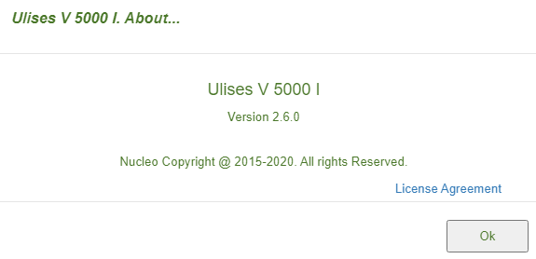

Figure 41. About

This screen shows the current version of the application and the ‘License Agreement’ link provides access to the file with the legal references for **Open Source** products, which will open in a new browser tab.

# Annex A. Centralized Services Supervision Screens.

The system manager of centralized services provides a series of web pages to monitor different aspects of the functioning of the system. These pages are accessed from the Supervision and Maintenance application, as described in 7.2.2.2.

This annex describes the screens, contents and operations offered.

The general format of the screen is shown in the figure below:

Header

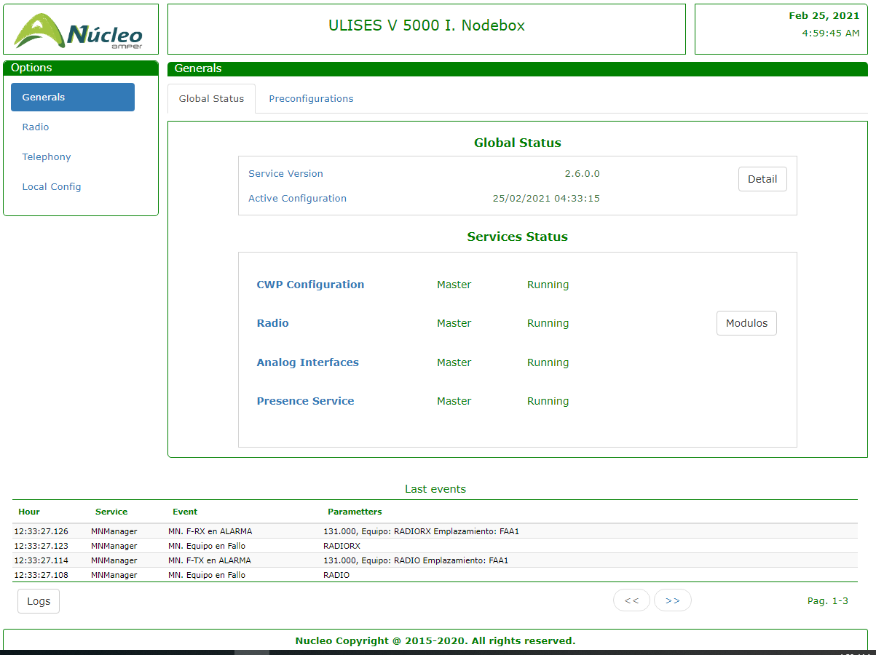

General Menu

Access to Logs

Information

Sub-options

Latest Events

Footer

Figure 42. Centralized Services. General Format of the Screen.

The following fields are displayed:

* Header. Includes the logo, application title and Date and Time (Local).
* General Menu. Located in the centre left area. It displays the general options offered to the operator, which are:
  + General. View of the general status of the Service.
  + Radio. View and control of the status of the radio service.
  + Telephony. View and control of the status of services associated with the telephony subsystem.
  + Local Config. Access to the most representative parameters of the radio service configuration.
* Information. Corresponds to the centre right area of the application. Used to display the values and options for each one of the general options offered by the Menu. It consists of two parts:
  + Selection of sub-options. In the form of tabs at the top.
  + Sub-option values. Located at the bottom.
* Latest Events. Located at the bottom, this shows the last events (that generated log entries) that occurred in the module, in ASCENDING order by time. The following information is shown for each event:
  + Hour: Time when the event occurred.
  + Service. Internal module that generated the event.
  + Event. Description of the generated event.
  + Parameters. Information associated with the event.

This information is presented in paginated form. The pagination controls are displayed on the bottom of the screen.

* Access control to module LOGS. Allows access to the detailed event log of the module, which is displayed in text mode.
* Footer. Located at the bottom.

## General Options

Made up of two sub-options:

* Global Status.
* Preconfigurations.

### Global Status

Shown in the figure below:

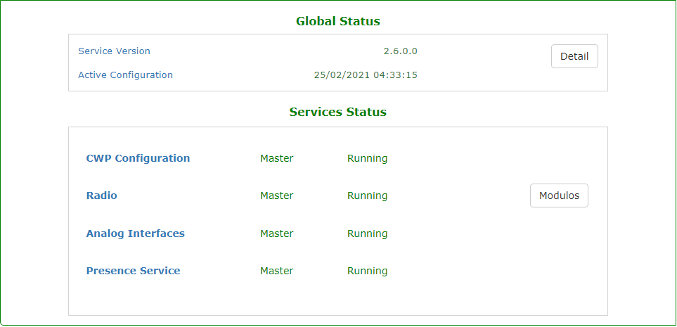

Figure 43. Centralized Services. General Options. Global Status.

Displays the following information:

* Global Status. Made up of the following fields:
  + Service Version. Shows the version of the software that is running on the radio server. The ‘Detail’ control provides detailed information on the software version of the subsystem.
  + Active Configuration. Shows the database identifier (Date and Time) of the configuration that the service is using.
* Services Status. The background colour indicates the status (GREEN: RUNNING, RED: ERROR). The following information is displayed for each one of the services:
  + Service: Service identifier:
    - CWP Configuration. Status and operating mode of the configuration service (CFGSERVICE).
    - Radio. Same as the previous one, but in regard to the Radio service (RDSERVICE). According to the configuration, the “Modules”[27] control shows the status of the different radio subsystems:
      * M+N. Refers to the MN radio management subsystem.
      * HF. Refers to the HF transmitter management subsystem.
      * 1+1. Refers to the 1+1 unit management subsystem.
    - Analogue Interfaces. Same as the previous one, but in regard to the TIFX service (TIFXSERVICE).
    - Presence Service. Same as the previous ones, but in regard to the SIP Telephony Resources presence agent.
  + Mode. Shows the operating mode of the corresponding service. It can take the following values:
    - Master.
    - Slave.
    - Stopped. The service is not running, normally because the configuration indicates that the service in question is not configured. This normally affects the PBX service.
  + Status: Shows the operational status of the service. This can take one of the following values:
    - Active. The service is running normally. This is the expected status for services that are in ‘master’ mode.
    - Waiting. The service is running but its functions are suspended. This is the expected status for services that are in ‘slave’ mode.
    - Stopped. The service is stopped, if the mode is not ‘Stopped’, it indicates an error in the execution of the service, which should be diagnosed.

### Local Pre-configuration management

It is shown in the following screen:

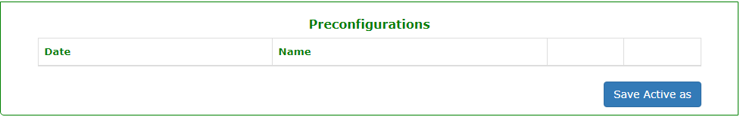

Figure 44. Centralized Services. General Options. Pre-configurations

On this screen, users may:

* Save and label copies of the active configuration.
* Delete previously saved pre-configurations.
* Activate previously saved pre-configurations.

The screen contains a list of existing pre-configurations. The following fields are displayed for each of them:

* Creation date.
* Pre-configuration name or identifier.
* Control of activation.
* Control of deletion.

The following procedures are established on this page:

1. **Save Configuration As**. The steps shown below should be followed:
   1. Enable the control “Save Active As”.
   2. Enter the name of the new pre-configuration and accept.
   3. The system will ask for additional confirmation through a pop-up message.
   4. If the action is confirmed, the user identification is requested and the pre-configuration is generated.
   5. If the operation is successful, this is shown by a pop-up message, and the list of available pre-configurations is updated.
   6. If an error occurs, this is indicated in a pop-up message and the operation is aborted.
2. **Delete Saved Configuration**. The steps shown below should be followed:
   1. Click the control “Delete” corresponding to the pre-configuration we want to activate.
   2. The system will ask for additional confirmation through a pop-up message.
   3. If the action is confirmed, the user identification is requested and the pre-configuration is deleted.
   4. If the operation is successful, this is shown by a pop-up message, and the list of available pre-configurations is updated.
   5. If an error occurs, this is indicated in a pop-up message and the operation is aborted.
3. **Activate saved configuration**. The steps shown below should be followed:
   1. Click the control “Activate” corresponding to the pre-configuration we want to activate.
   2. The system will ask for additional confirmation through a pop-up message.
   3. If the action is confirmed, the user identification is requested and the pre-configuration is activated.
   4. If the operation is successful, this is shown by a pop-up message, and the list of available pre-configurations is updated.
   5. If an error occurs, this is indicated in a pop-up message and the operation is aborted.

## Radio Options

This consists of four sub-options:

* Active Sessions.
* M+N Manager.
* HF transmitters.
* 1+1 Manager.

### Radio Sessions

This screen displays a list of radio sessions (SIP) managed by the MANAGER.

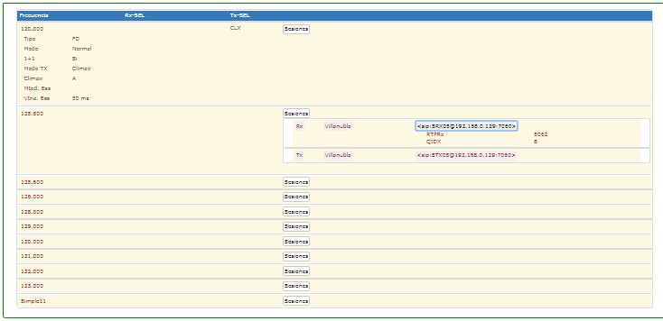

Figure 45. Radio Options. Active Sessions.

The structure, content and meaning are the same as described in 7.3.1.

### M+N Manager

Displays the configuration and status of the VHF-band radio units (IP radios), associated with the M+N Manager.

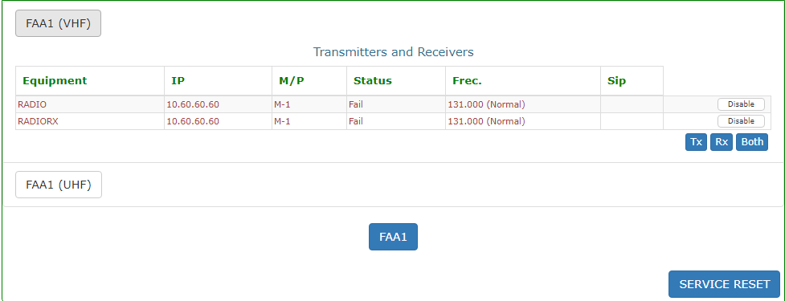

Additional controls

Figure 46. Radio Options. M+N Manager (VHF)

The structure, content and meaning are the same as described in 7.3.2. In addition to this information, there are commands associated with the units:

* *Assign*. Only available for available STANDBY type units, allows a standby unit to be tuned manually. The use of this command deactivates the associated unit (if not already deactivated). To return the unit to Available status, the Enable command must be executed.
* *Enable/Disable*. Depending on the status (Enabled/Disabled), this command Disables[28] or Enables the unit in the manager PLC. This command is available in all units. When it is clicked, and after additional confirmation, the command is sent to the manager and is executed[29].
* *Service RESET*. After additional confirmation, this allows the M+N management service to be reset.

### HF transmitters

This section displays the operational status of the HF radio Transmitter Assignment manager[30]. It looks like this:

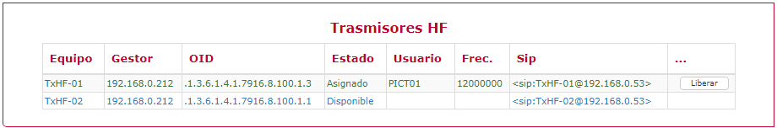

Site Units

Manual Release Control

Figure 47. Management of HF radio Transmitter Assignment.

The following information is displayed for each element in the list:

* **Equipment**. Identifier of the radio resource associated with the HF transmitter.
* **Manager.** IP address of the SNMP manager associated with the Remote-control subsystem.
* **OID.** SNMP base address in the manager associated with the HF transmitter unit.
* **Status**. Indicates the availability of the unit in the HF management subsystem. It can take the following values:
  + Not Initialized.
  + Available.
  + Assigned.
  + Fail.
  + Disabled.
* **User.** Indicates the operator, who in such case (Assigned) has the Transmitter occupied.
* **Freq**. Indicates the frequency to which in such case (Assigned) the unit is tuned.
* **SIP**. URI associated with the radio resource.
* **Release.** Control to manually release assigned units.

### 1+1 Manager

This section shows the operating status of the 1+1 equipment control subsystem’s elements. It will only be visible for the installations that contain these types of elements.

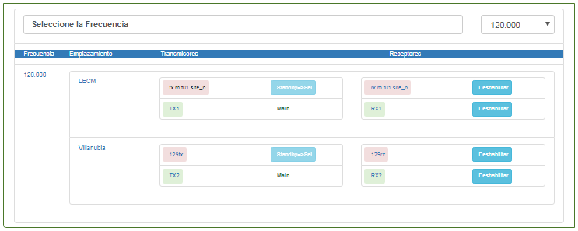

Receivers in 1+1

Transmitters in 1+1

Site

Selected Frequency

Frequency Selector

Figure 48. 1+1 Manager.

The structure, content and meaning are the same as described in 7.3.3.

## Telephony Options

This consists of four sub-options:

* Proxies
* Analogue Interfaces
* PBX Subscribers
* External ATS Subscribers

### Proxy Availability

This screen displays the availability status of the SIP Proxy elements configured in the system. The information is displayed on the following screen:

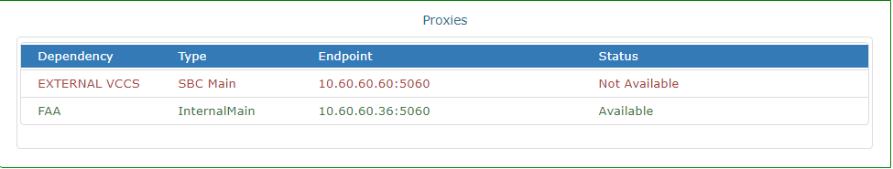

Figure 49. Telephony Options. SIP Proxy Availability.

This screen shows a list of the external SIP PROXY elements that have been configured in the system. The following information is displayed for each element:

* Dependence: Identifier of the dependence to which the element corresponds.
* Type: Identifies the role adopted by the element in the SIP management of the dependence to which it belongs. The defined roles or types are the following:
  + Local-Main. This refers to the PROXY of the dependence that is configured as the main or default proxy.
  + Local-Alternative. This refers to the PROXIES of the dependence that are configured as alternatives to the main or default proxy.
  + External-Main. This refers to the PROXIES of the external dependences that are configured as main or default proxy for the dependence.
  + External-Alternative. This refers to the PROXIES of the external dependences that are configured as alternative to the main or default proxy for the dependence.
* Endpoint: Refers to the IP / Port pair where the service of the referenced SIP PROXY is located.
* Status: Indicates the connectivity status for system presence agent for the selected element. The possible statuses are:
  + Available. The element responds to the poll that the agent carries out. In this status, the text is displayed in GREEN.
  + Not Available. The element DOES NOT RESPOND to the poll that the agent carries out. In this status, the text is displayed in RED.

### Status of Analogue Interfaces

Displays the availability status of the different analogue telephone interfaces, based on the information collected by the TIFX service. This information is structured in the following screen:

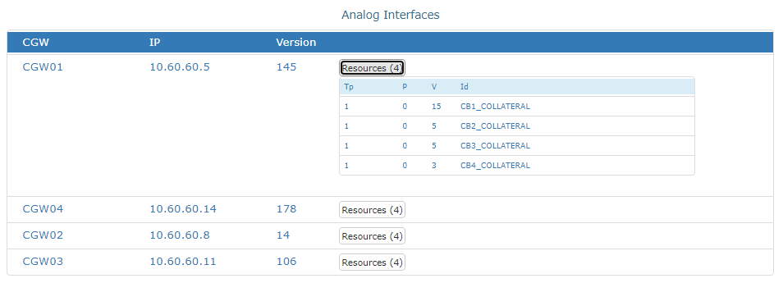

Figure 50. Telephony Options. Status of Analogue Interfaces.

This screen displays a two-level list of the statuses of analogue telephony interfaces.

The first level is made up of the interface units (Gateways) that are reporting the statuses. The following information is shown for each gateway:

* CGW: Gateway identifier.
* IP: IP address of the Gateway.
* Version: Of the Gateway message[31].
* Resources: Display control of the interfaces of the gateway whose status is being reported. The control indicates the number of reported interfaces in brackets. When this control is clicked, it opens the second level of information: The information regarding each Resource:
  + Tp: Resource Type. The possible values are 1: ‘Telephony’, 2: ‘Hotline’.
  + P: Priority. For interfaces to ATS networks in conversation, indicate the conversation priority.
  + V: Version of the resource message[32].
  + Id: Resource identifier.

### PBX Subscriber Status

Displays the registration and availability status of the different subscribers in the internal PBX, based on the information collected by the PBX service. This information is structured in the following screen:

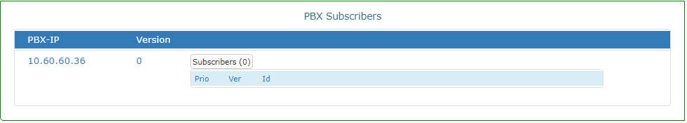

Figure 51. Telephony Options. Registered Subscriber Status.

This screen displays a two-level list of the statuses of the registered subscribers.

The first level is made up of the information associated with the PBX:

* PBX-IP: IP address of the PBX.
* Version: Of the PBX message[33].
* Subscribers: Display control of the registered subscribers. The control indicates the number in brackets. When this control is clicked, it opens the second level of information: The information regarding each Subscriber:
  + Prio: Priority.
  + V: Version of the subscriber message[34].
  + Id: Subscriber ID.

### Availability of External ATS-SIP Subscribers

This screen displays the availability status of the external ATS-SIP destinations that have been configured in the system. The information is displayed on the following screen:

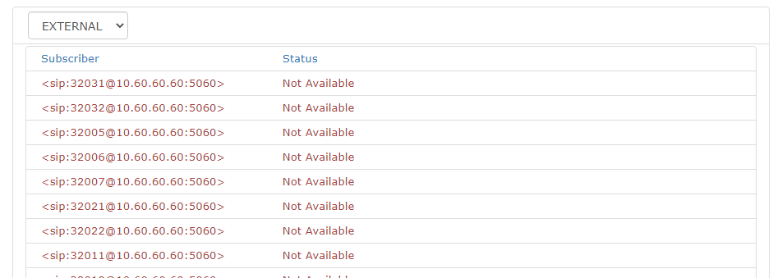

Figure 52. Telephony Options. Availability of External ATS-SIP Destinations.

This screen shows a list of the external ATS-SIP destinations that have been configured in the system. It consists of a dropdown window with the different configured dependences. When one is selected, a list drops down with the subscribers of the dependence in question.

The following information is displayed for each element:

* Subscriber: Indicates the presence URI (with which it would be registered in the presence service of the dependence in question).
* Status: Indicates the connectivity status for system presence agent[35] for the selected element. The possible statuses are:
  + Available. In this status, the text is displayed in GREEN.
  + Not Available. In this status, the text is displayed in RED.

## Local Configuration

Indicates the value and the possibility of changing some of the operational parameters of the service (local ***.config*** file).

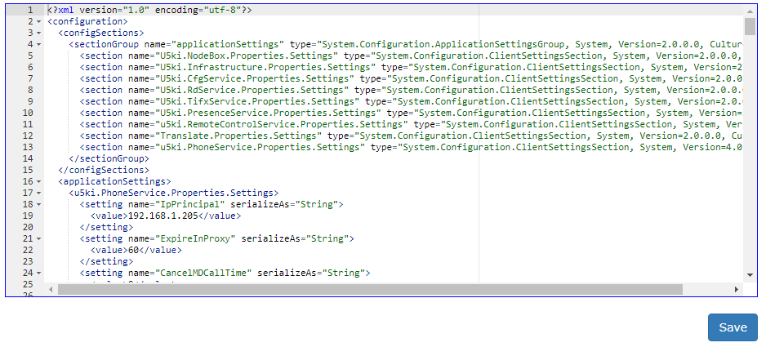

Figure 53. Local Configuration.

The data is changed directly from the editor provided and is saved by clicking on “Save Changes” (password protected).

**This editor should only be used by advanced maintenance personnel.**

# Legal Information

**Open-source licences**

|  |  |  |  |  |  |  |
| --- | --- | --- | --- | --- | --- | --- |
| **OPEN SOURCE CODE SOFTWARE** | **VERSION** | **COPYING** | **COPYING.**  **LESSER** | **COPYING.**  **AFFERO** | **LICENSE** | **URL DOWNLOAD** |
| MySQL Database Community Edition | 5.6.11 | X |  |  | GPL v2.0 | <https://www.mysql.com/products/community> |
| Runtime Crystal Reports | 13.0.9 |  |  |  | Free Internal Distribution | https://wiki.scn.sap.com |
| NLOG | 4.2.3 | X |  |  | BSD-3-Clause | https://www.nuget.org/packages/NLog/4.2.3 |
| WebSocket4Net | 0.14.1 | X |  |  | Apache-2.0 | https://www.nuget.org/packages/WebSocket4Net/ |
| JSON.NET | 7.0.1 | X |  |  | MIT | https://www.nuget.org/packages/Newtonsoft.Json/7.0.1 |
| #Snmp Library | 8.5.0.0 | X |  |  | MIT | https://www.nuget.org/packages/Lextm.SharpSnmpLib/8.5.0 |
| PJ-SIP | 1.6 | X |  |  | GPL v2.0 | <http://www.pjsip.org/download.htm> |
| Spread toolkit | 4.4.0 | X |  |  | Spread Open-Source | <http://www.spread.org/download.html> |
| ASIO | 2.10 | X |  |  | Particular license | <http://www.asio4all.com/> |
| NLOG | 3.1.0.0 | X |  |  | BSD-3-Clause | https://www.nuget.org/packages/NLog/3.1.0 |
| JSON.NET | 8.0.2 | X |  |  | MIT | https://www.nuget.org/packages/Newtonsoft.Json/8.0.2 |
| #Snmp Library | 7.0.0.1 | X |  |  | MIT | https://www.nuget.org/packages/Lextm.SharpSnmpLib/7.0.0.2 |
| INI.Parser | 2.3.0 | X |  |  | MIT | https://www.nuget.org/packages/ini-parser/2.3.0 |
| Naudio | 1.7.3 | X |  |  | MS-PL | https://www.nuget.org/packages/NAudio/1.7.3 |
| O.S. Yellow Dog | 2.4.1 | X | X |  | GPL v2.0, LGPL v.2.1 | http://www.fixstars.com/en/technologies/linux/ |
| oSip Library | 2.3.5 |  | X |  | LGPL v3 | <ftp://ftp.gnu.org/gnu/osip> |
| xOSip Library | 2.3.5 | X |  |  | GPL v2.0 | <http://download.savannah.nongnu.org/releases/exosip/> |
| jRtp Library | 3.7.1 | X |  |  | MIT | http://research.edm.uhasselt.be/jori/page/CS/Jrtplib.html |
| Snmp++ Library | 3.3.1 | X |  |  | Particular license | http://agentpp.com/download.html |
| Agent++ Library | 4.0.2 | X |  |  | Apache 2 Open Source | http://agentpp.com/download.html |
| mongoose server | 5.6 | X |  |  | GPL v2.0 | https://github.com/cesanta/mongoose/releases/tag/5.6 |
| Rapid-Json | 1.0.2 | X |  |  | MIT | https://www.nuget.org/packages/rapidjson/1.0.2 |
| Rapid-xml | 1.13 | X |  |  | BSL-1.0/MIT | <https://www.nuget.org/packages/rapidxml/1.13.0> |
| jQuery | 2.1.3 | X |  |  | [MIT/Boost Software License](https://jquery.org/license/) | https://code.jquery.com/jquery/ |
| Angular JS | 1.5.3 | X |  |  | MIT | https://code.angularjs.org/1.5.3/ |
| Bootstrap | 3.3.5 | X |  |  | MIT | https://github.com/twbs/bootstrap#copyright-and-license |
| Virtual Box | 5.0.0 | X |  |  | GPL v2.0 | https://www.virtualbox.org/wiki/Download_Old_Builds_5_0 |

**Licences in COPYING, COPYING.LESSER and/or COPYING.AFFERO.**

|  |  |
| --- | --- |
|  |  |
| **COPYING** |  |
| **COPYING.LESSER** |  |
| **COPYING AUTHORIZATION** |  |

# GLOSSARY

|  |  |
| --- | --- |
| **A/G** | Air / Ground |
| **ACC** | Area Control Centre |
| **DA** | Direct Access |
| **IA** | Indirect Access |
| **ATM** | Air Traffic Management |
| **ATS** | Air Traffic System |
| **ATS-N5** | UIT-N5 Protocol for ATS |
| **ATS-QSIG** | QSIG protocol in ATS systems |
| **ATS-R2** | R2 protocol in ATS systems |
| **CB** | Central Battery |
| **LB** | Local Battery |
| **BROADCAST** | Means of transmitting to all devices on a network |
| **CELP** | Code excited linear prediction. Voice encoding algorithm |
| **CODEC** | Encoder-Decoder |
| **COTS** | Commercial Off The Shelf |
| **CPU** | Central Processing Unit |
| **DTMF** | Dual-tone multi-frequency signalling. Analogue Telephony Protocol |
| **ETHERNET** | LAN networks standard |
| **ETM** | Multi-protocol Test Equipment |
| **ETSI** | European Telecommunications Standards Institute |
| **EUROCAE** | European Organization for Civil Aviation Equipment |
| **FULL-DUPLEX** | Simultaneous send and receive transmission mode |
| **FXO** | Foreign eXchange Office. Subscriber mode telephone interface. |
| **FXS** | Foreign eXchange Station. Central Mode Telephone Interface |
| **HF** | High Frequency. Electromagnetic spectrum band in the frequency range of 3 MHz to 30 MHz |
| **HMI** | Human Machine Interface |
| **HTTP** | Hypertext Transfer Protocol |
| **IP** | Internet Protocol. Basic communications protocol |
| **IPDV** | IP PACKET DELAY VARIATION. See JITTER |
| **JITTER** | Deviation or displacement in a periodic parameter of a signal. |
| **LAN** | Local Area Network |
| **NEHL** | Normalised External Hotline |
| **LD-CELP** | Low-Delay Code Excited Linear Prediction |
| **MEDIA** | Information contained in a transmission |
| **MULTICAST** | Information sent over a network to multiple destinations simultaneously |
| **NTP** | Network Time Protocol. Network synchronisation protocol |
| **ICAO** | International Civil Aviation Organisation |
| **PABX** | Private Automatic Branch Exchange. Telephone exchange |
| **PROXY** | Program or device that performs an action in representation of another. |
| **ERSS** | Equipment Room Supervision Station |
| **ORSS** | Operations Rooms Supervision Station |
| **PTT** | Push to talk |
| **QSIG** | ISDN-based Telephony Signalling Protocol |
| **RAM** | Random Access Memory |
| **ISDN** | Integrated Services Digital Network |
| **ISDN-B** | Integrated Services Digital Network Basic Interface. |
| **RFC** | Request for Comments |
| **RTCP** | Real time control protocol. RTP sessions control |
| **RTP** | Real-time Transport Protocol. Protocol for transporting data over IP |
| **SACTA** |  |
| **VCS** | Voice Communications System |
| **SDP** | Session Description Protocol |
| **SIP** | Session Initiation Protocol. Session Management Protocol over IP |
| **SNIFFER** | Software or Hardware element that can intercept and log data network traffic |
| **SNMP** | Simple Network Management Protocol. IP networks Management Protocol |
| **SOAP** | Simple Object Access Protocol |
| **SQUELCH** | Indicates presence of a Valid Signal in Radio Reception |
| **G/G** | Ground / Ground |
| **TACC** | Terminal Area Control Centre |
| **TCP** | Transmission Control Protocol |
| **TWR** | Control Tower |
| **SCU** | Sector Control Unit |
| **UDP** | User Datagram Protocol |
| **UHF** | Ultra-High Frequency. Electromagnetic spectrum band in the frequency range of 300 MHz to 3 GHz. |
| **UIT-T** | UIT Telecommunications Standardisation Sector |
| **UNICAST** | Means of sending information from a single sender to a single recipient |
| **USB** | Universal Serial Bus |
| **VHF** | Very High Frequency. Electromagnetic spectrum band in the frequency range of 30 MHz to 300 MHz |
| **VoIP** | Voice over IP. Technology for transmitting audio signals in IP data packets |
| **WAN** | Wide Area Network |
| **WEB** | World Wide Web. System of documents connected by hypertext links, available on a network. |
| **XML** | Extensible Markup Language |

Table 11. Glossary of Abbreviations

1. This service is Optional.
2. This service is Optional.
3. See the annex on the presence agent in the General description of the system for details on the procedures and criteria that are used to determine the presence of internal or external telephone resources.
4. The content of this field consists of 8 characters, with each one encoding the status of 1 up to 8 LANs. The status codes are the same ones described for ‘stdgStd’ plus the code ‘9’, which means that the INTERFACE does not exist. The encoding is ASCII instead of BINARY.
5. The content of this field is the result of the execution of the WINDOWS command “w32tm /query /peers”. The Line ends have been replaced with the string “##”.
6. The content of this field consists of 8 characters, with each one encoding the status of 1 up to 8 LANs. The status codes are the same ones described for ‘stdgStd’ plus the code ‘9’, which means that the INTERFACE does not exist. The encoding is ASCII instead of BINARY.
7. The content of this field is a STRING where the list of NTP servers configured on the server (MEINBERG) and their connection status is encoded. The format is as follows: <server-1>:<status>##<server-2>:<status>…., where:

   <Server1>, <Server2>… Encodes the network id or IP address of the server.

   <Status>, Marked ‘synchronized’ or ‘not synchronized’.
8. Depending on the sectorization implemented, each position can have several URIS. When this happens, they are separated in this field by the string “##”.
9. The content of this field consists of 8 characters, with each one encoding the status of 1 up to 8 LANs. The status codes are the same ones described for ‘stdgStd’ plus the code ‘9’, which means that the INTERFACE does not exist. The encoding is ASCII instead of BINARY.
10. The content of this field is a STRING where the list of NTP servers configured on the server (MEINBERG) and their connection status is encoded. The format is as follows: <server-1>:<status>##<server-2>:<status>…., where:

    <Server1>, <Server2>… Encodes the network id or IP address of the server.

    <Status>, Marked ‘synchronized’ or ‘not synchronized’.
11. Each card status is encoded by an ASCII character. The status codes are the same ones described for ‘pasarelaStd’.
12. This status will be available in future versions.
13. Only in servers in CLUSTER configurations.
14. If there is an ‘abnormal’ status, the text will be displayed in RED.
15. If there are any inconsistencies in the Database, the text will be displayed in RED.
16. If there is an ‘abnormal’ status, the text will be displayed in RED.
17. Not all services need to be selected as the Master in the NBX Master (they negotiate as independent services). The Maintenance Service checks whether the Radio Service is selected as a master or not.

    In some cases, an error might occur if “CFG” was selected as the Master in an NBX and all other services were selected as the Master in another NBX; the machine with CFG as the Master could be down and no other NBX would pick up the service as the Master.
18. This survey is not done for Recorders.
19. The graphic will be different depending on the brand of the unit and whether it is a receiver or a transmitter.
20. Only the available resources are notified. Those that are not available (due to errors or internal functional faults) are not shown.
21. They must be defined as telephone resources in the configuration of the system.
22. See the presence agent annex for more information on the criteria used to establish the availability of external ATS-SIP destinations.
23. It presents up to the last 1000 events that fulfil the conditions of the filter.
24. Default version.
25. The identification provider must be MD5
26. The encryption provider must be DES
27. If there are no elements configured for a radio subsystem or module, it will not appear in the list or in other selection tabs.
28. The disabling of a unit means that it does not enter in the assignment/unassignment algorithms of the manager’s PLC.
29. All of these actions are recorded in the system’s general log.
30. If there are no HF transmitter units configured, the screen will be blank.
31. Information for MTTO
32. Ibid.
33. Information for MTTO
34. Ibid.
35. See the presence agent annex for more information on the criteria used to establish the availability of external ATS-SIP destinations.